Getting Started with Scratch
  - UoN Coding & STEM 4 Schools – Introduction Workshop 2019

Introduction
This tutorial is a quick introduction to Scratch – a visual programming language that can be used to build interactive stories, games and animations.

Acknowledgements
This tutorial has been adapted using content from the Getting Started with Scratch Guide version 2.0 created by the Lifelong Kindergarten Group available here: hckmd.com/getstarted2
The images have been updated to match the new Scratch 3 layout and blocks.

Getting Started
Scratch will run in most web browsers without installing additional software. This includes browsers such as Internet Explorer, Mozilla Firefox and Google Chrome. Today we’ll be using Mozilla Firefox, which you can open by clicking the Start Menu, going to All Programs then selecting Mozilla Firefox.
The Scratch website is https://scratch.mit.edu/ Start by opening that in Firefox.
From the website you can open the Scratch Editor (by clicking Create), see programs that students all over the world have created (by clicking Explore), or view the Scratch discussion boards (by clicking Discuss).
When you’re ready to start making a visual program, click Create to open the Scratch Editor. You should see something like the image below.
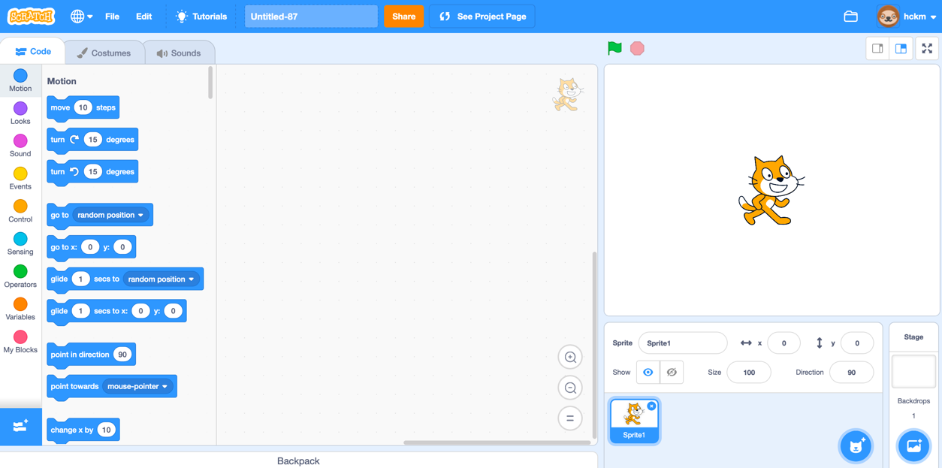

Start Moving

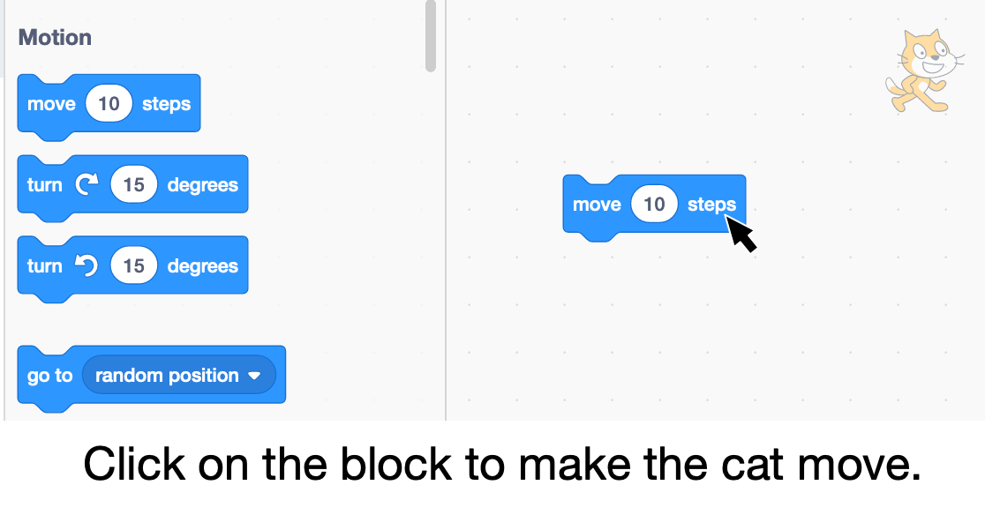

Add a Sound

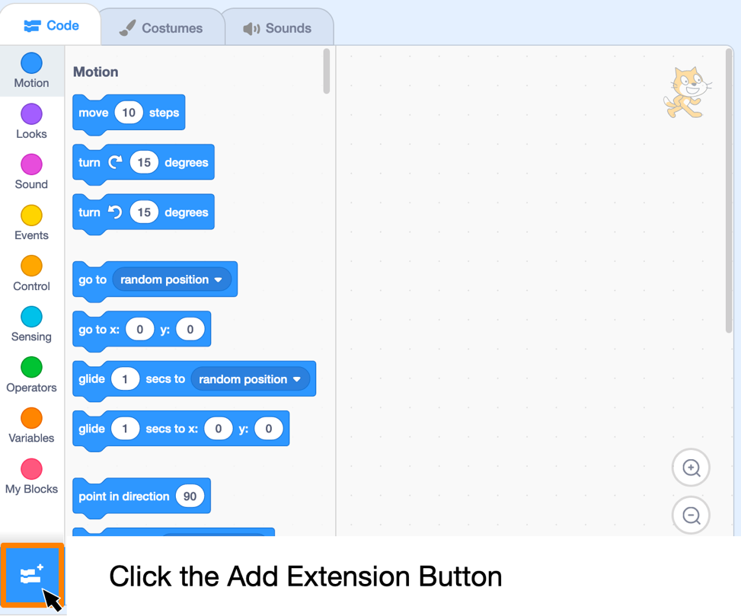

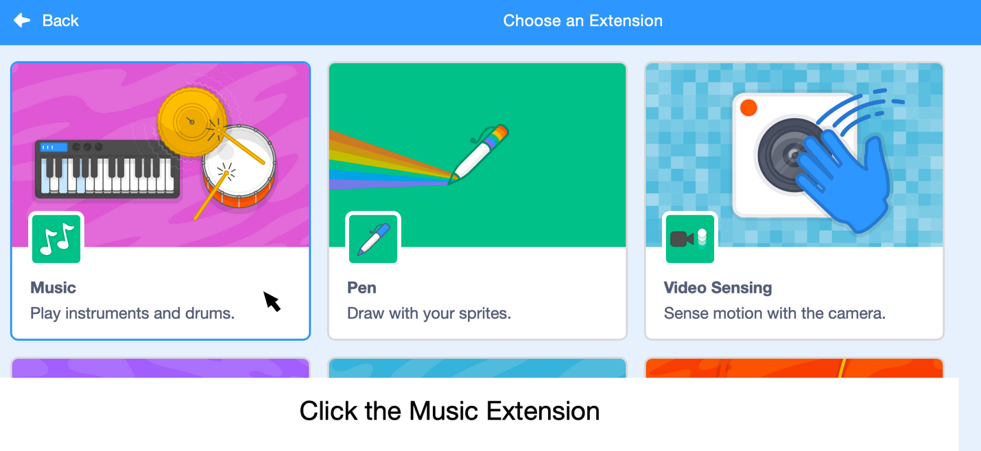

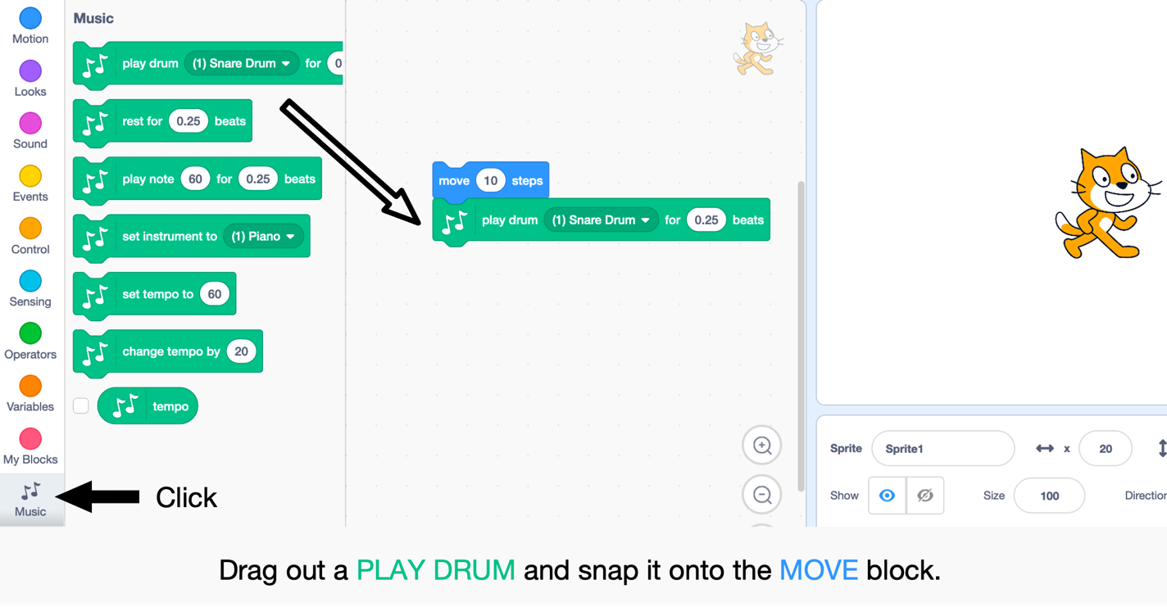
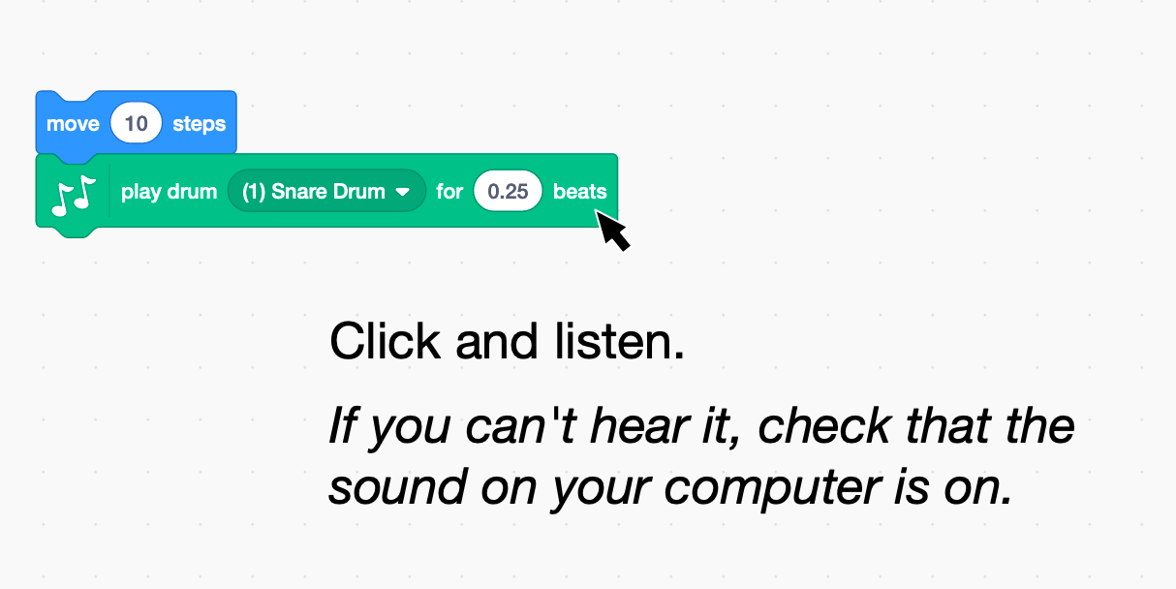
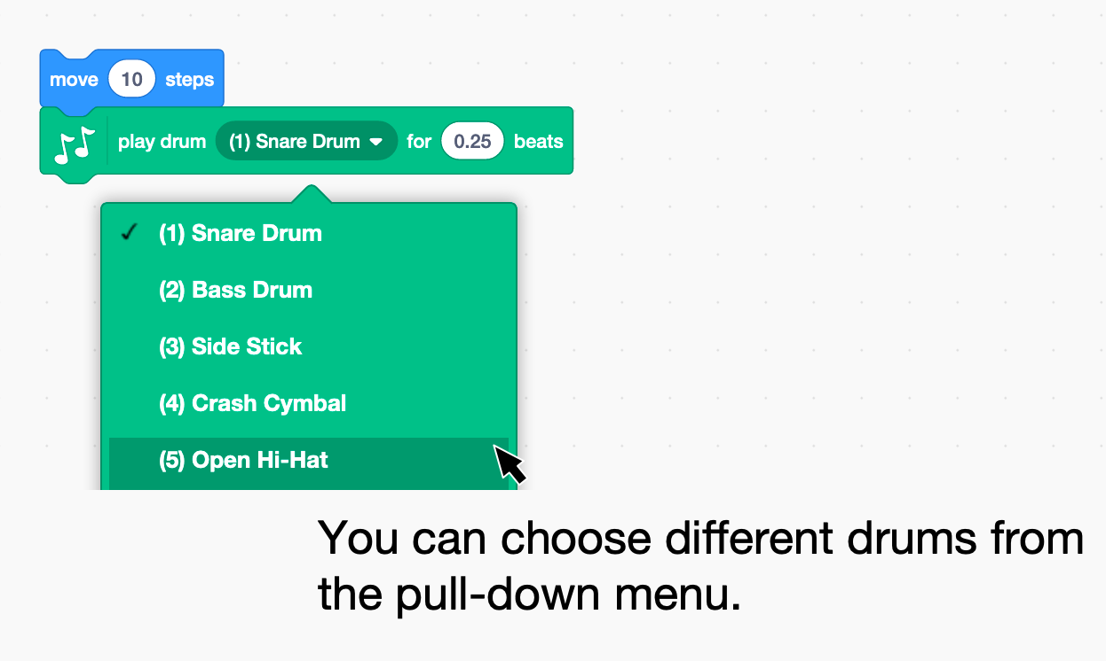

Start a Dance
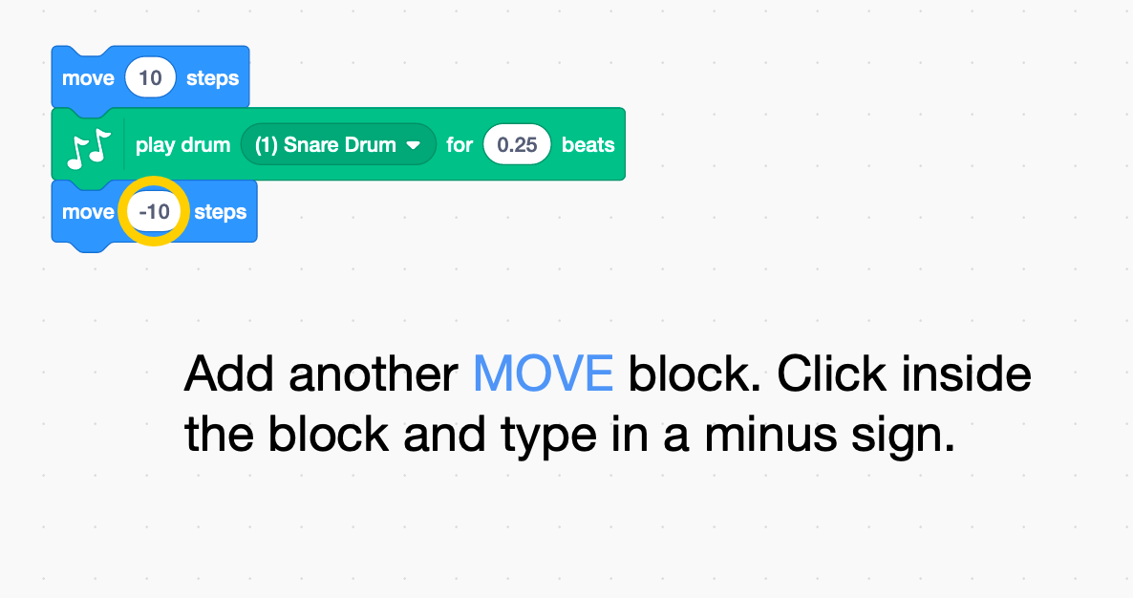
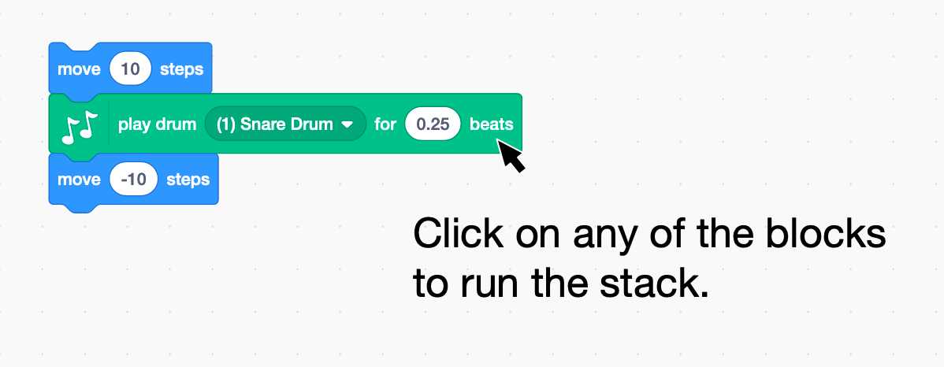
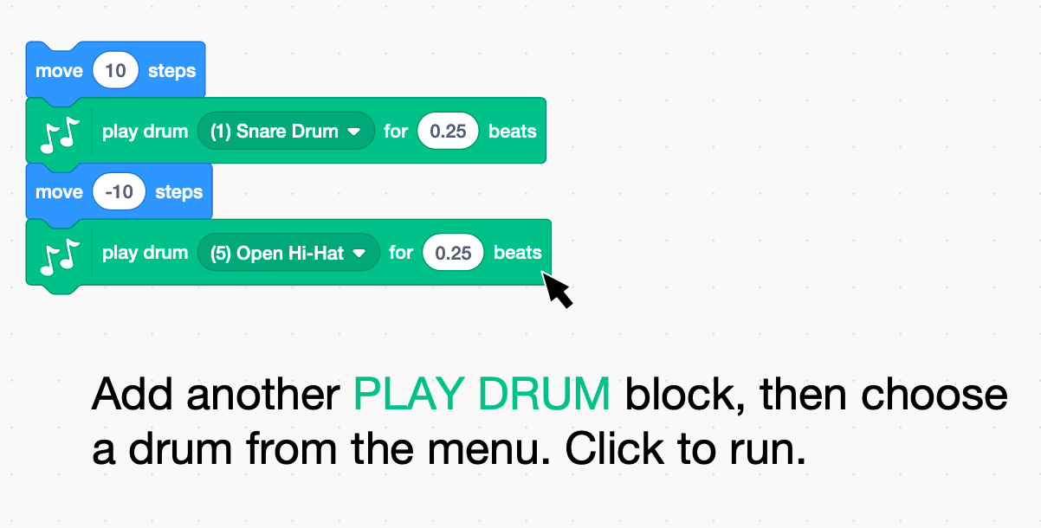

Again and Again

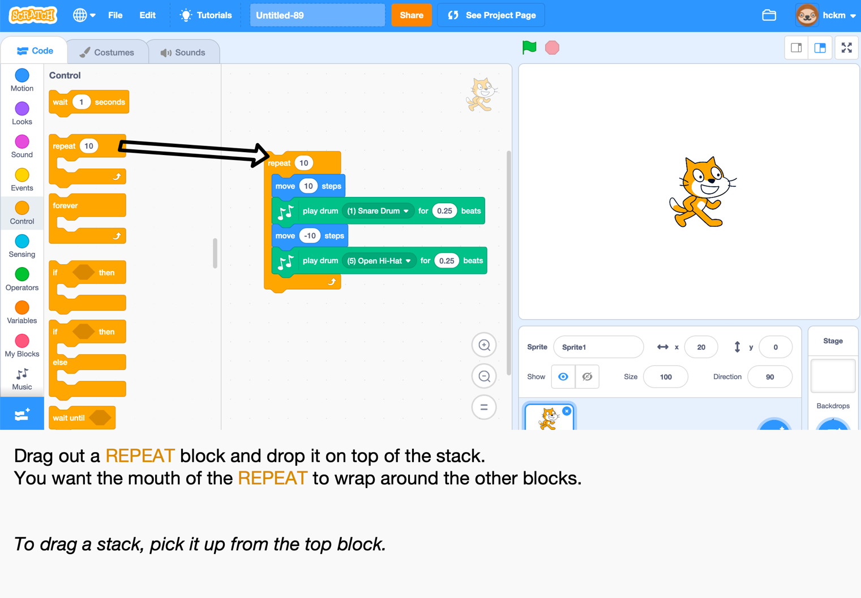
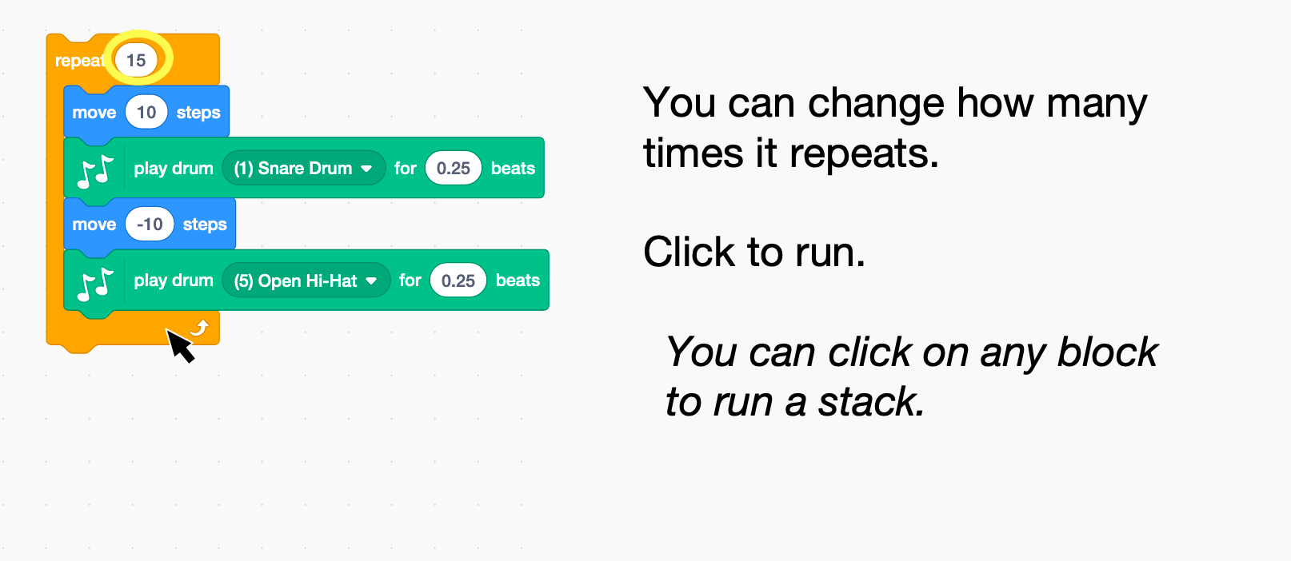

Say Something
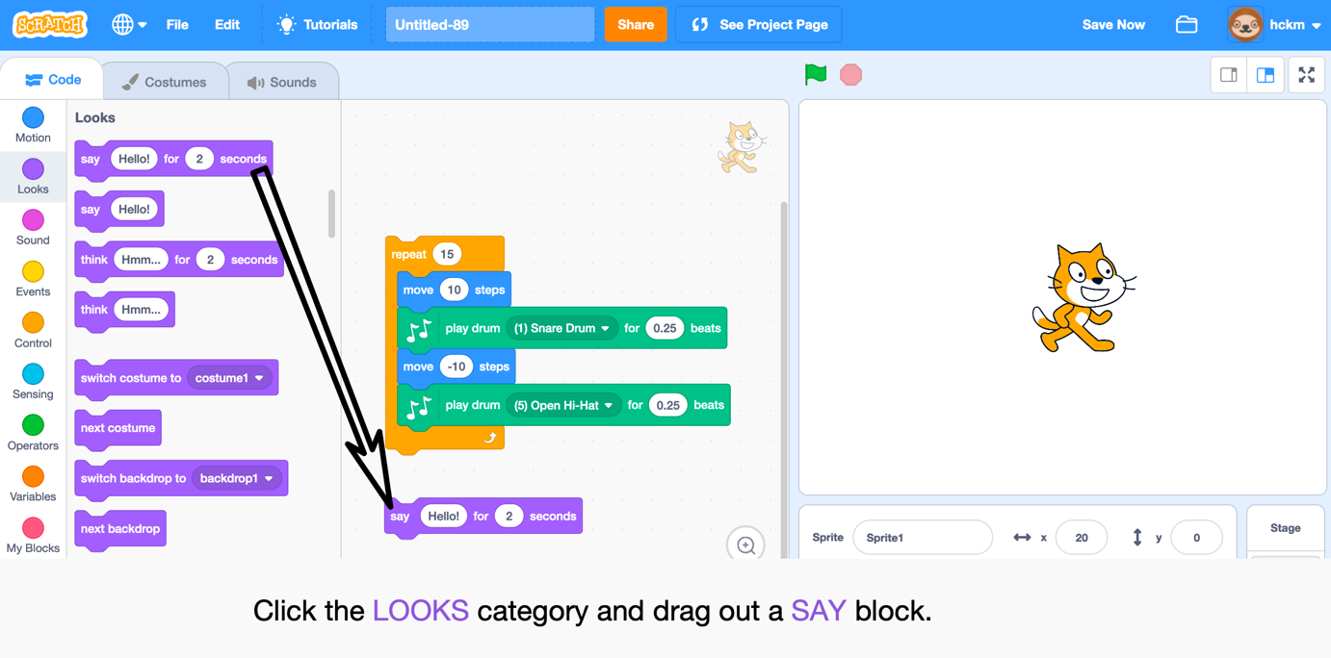
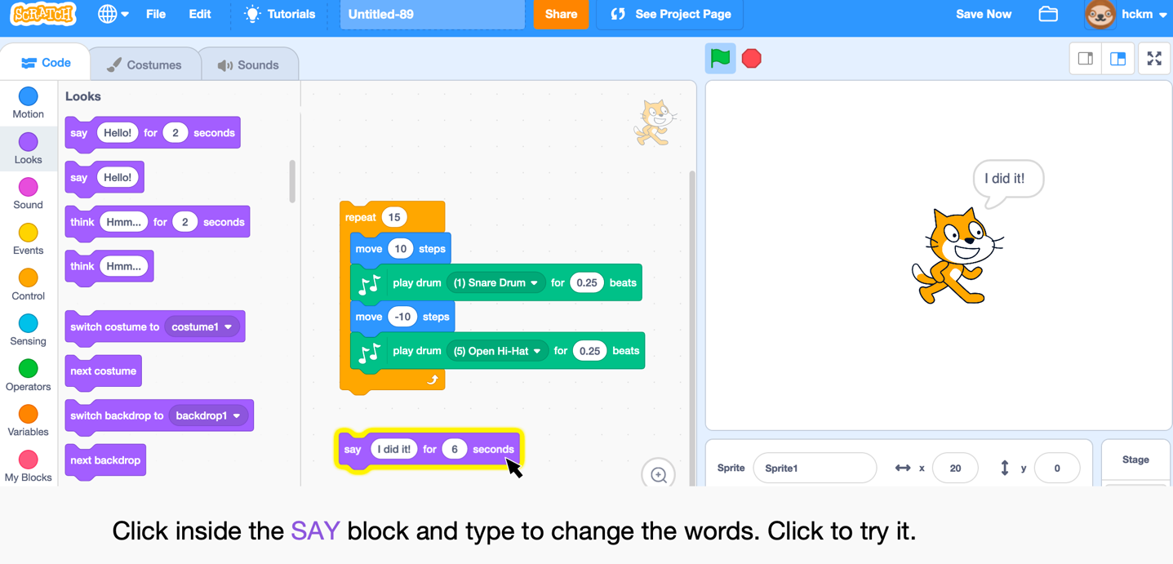
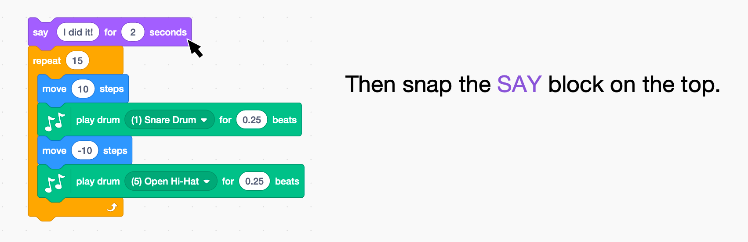

Green Flag

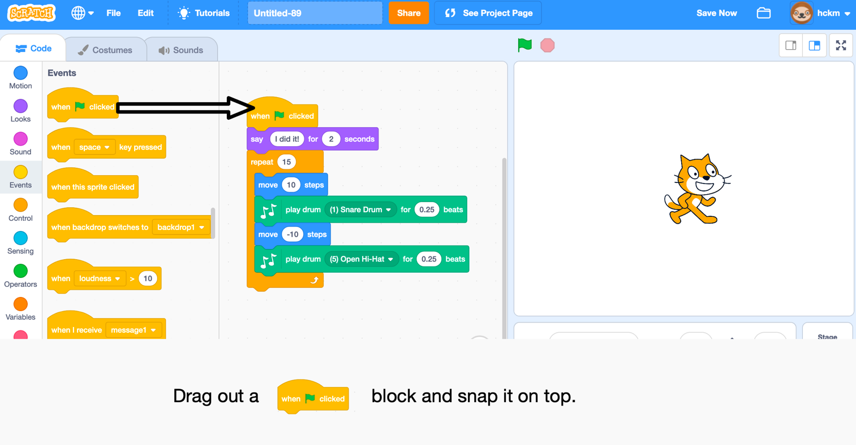
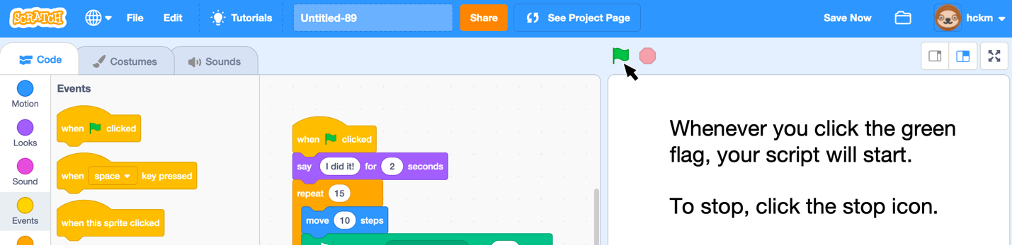

Change Colour

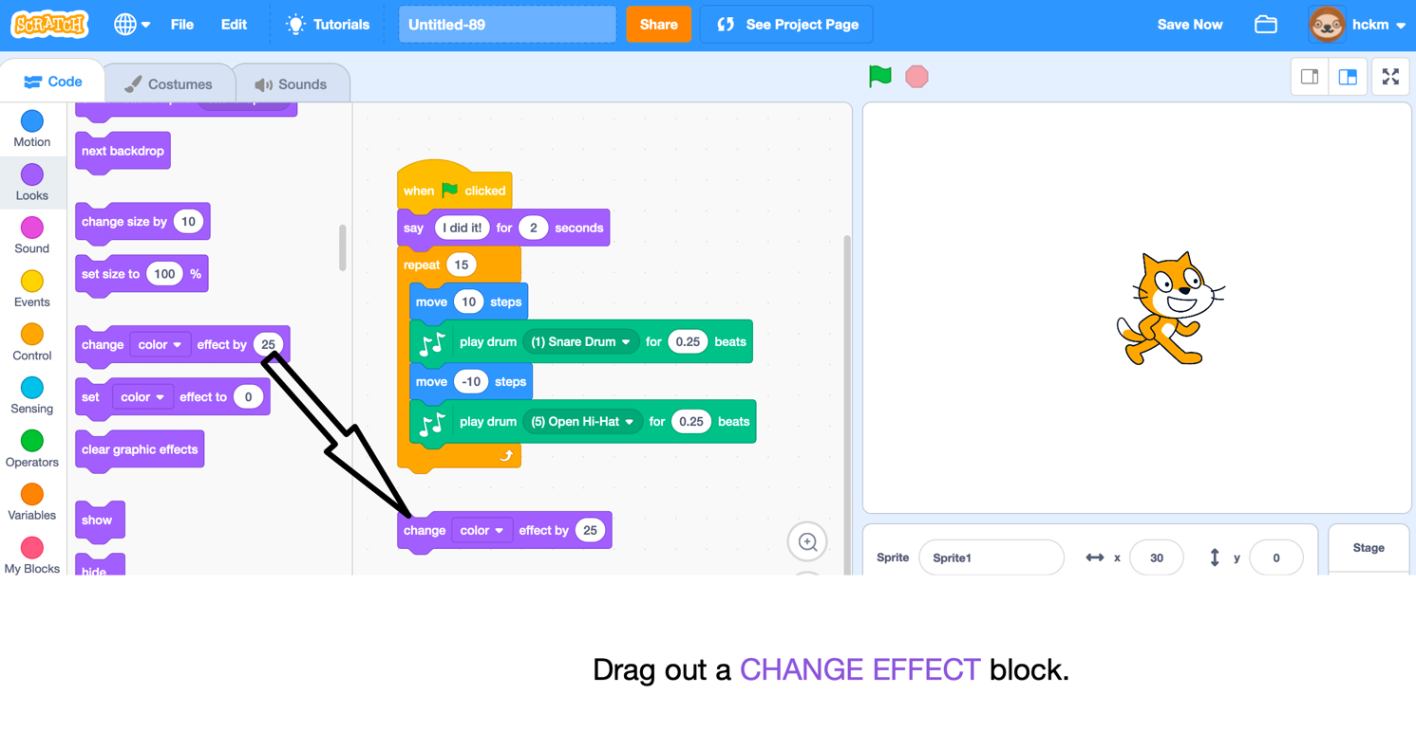

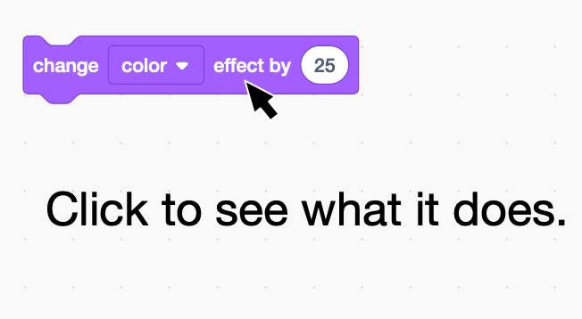

Key Press

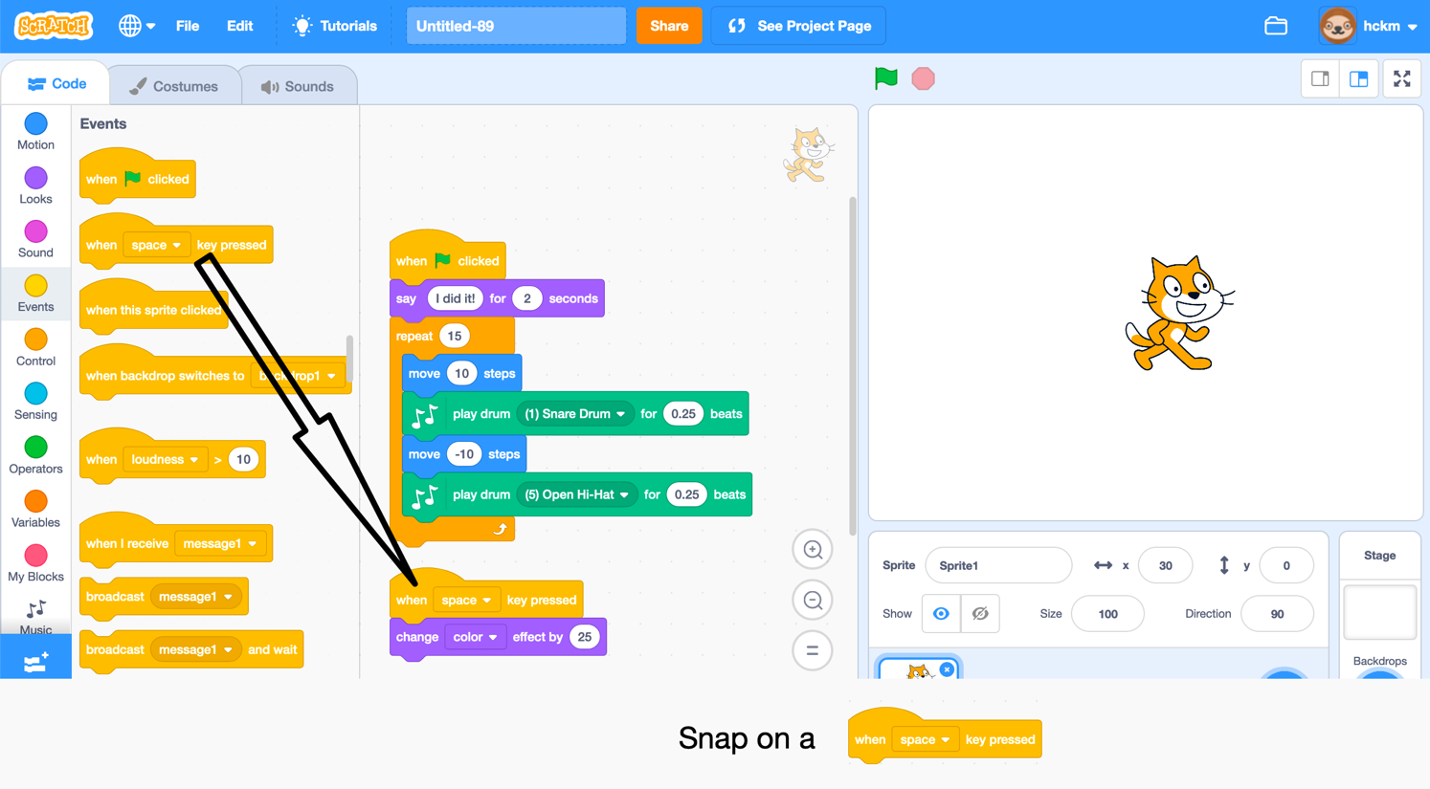
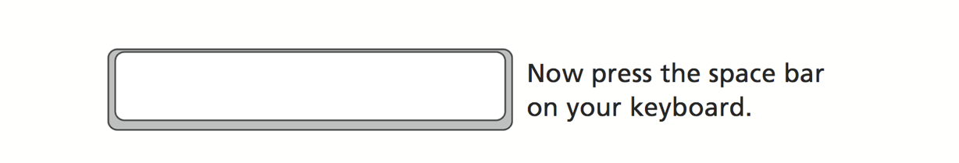
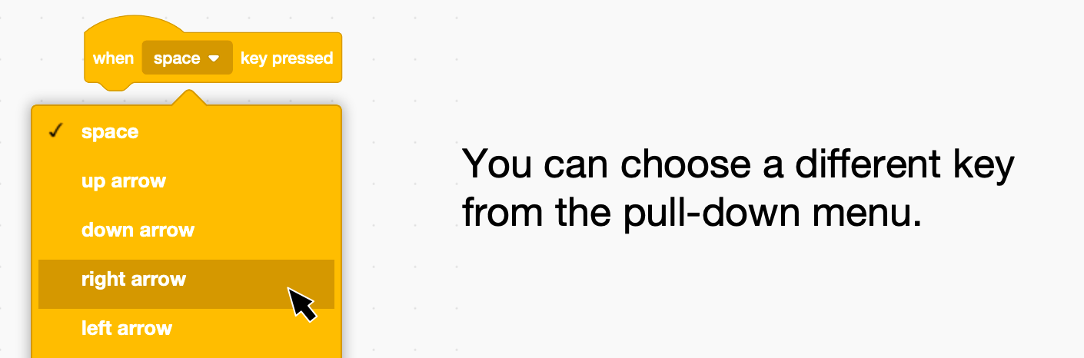

Add a Backdrop
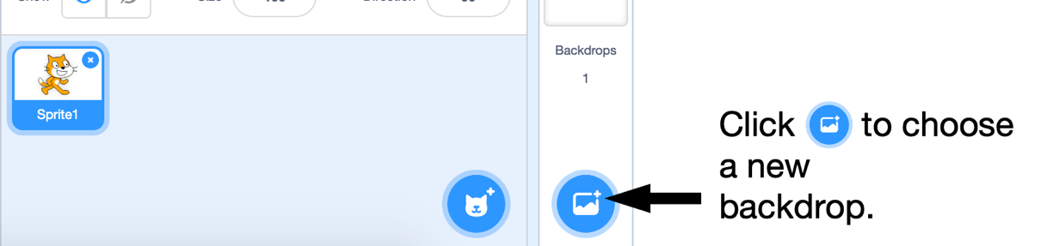
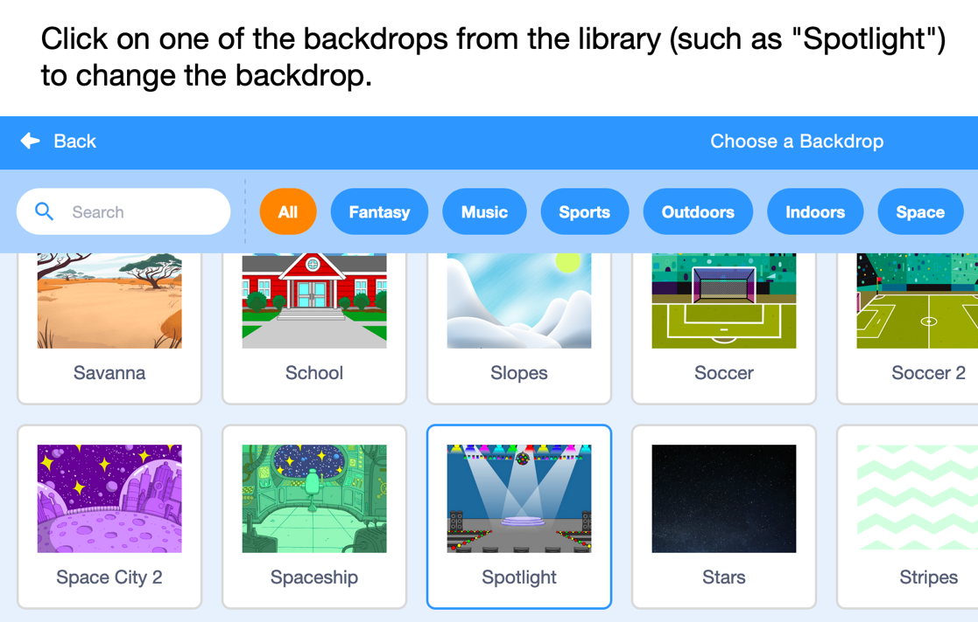
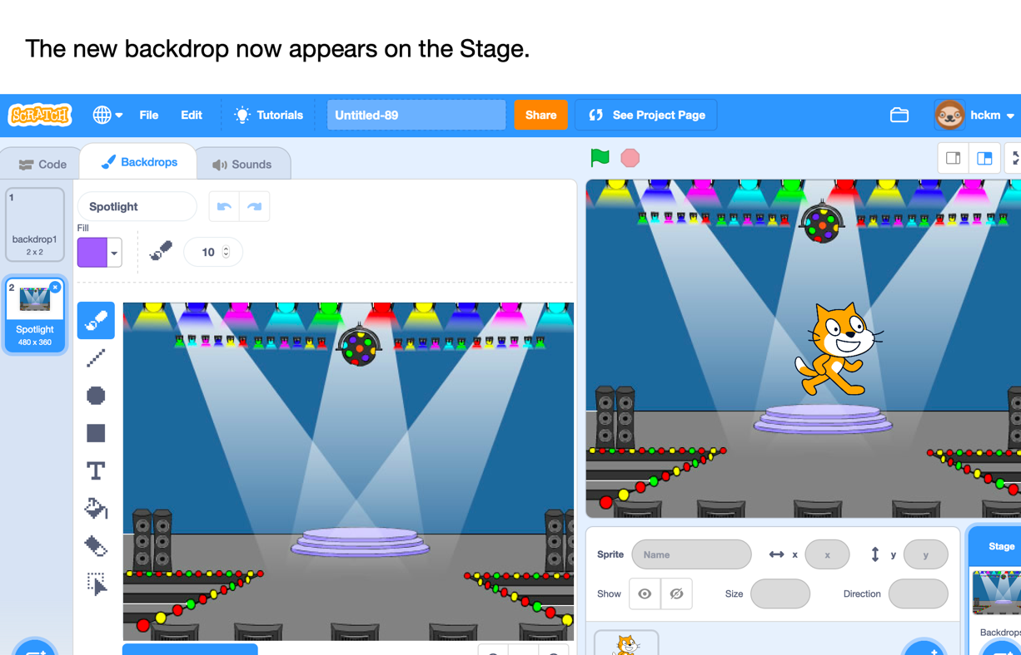

Add a Sprite

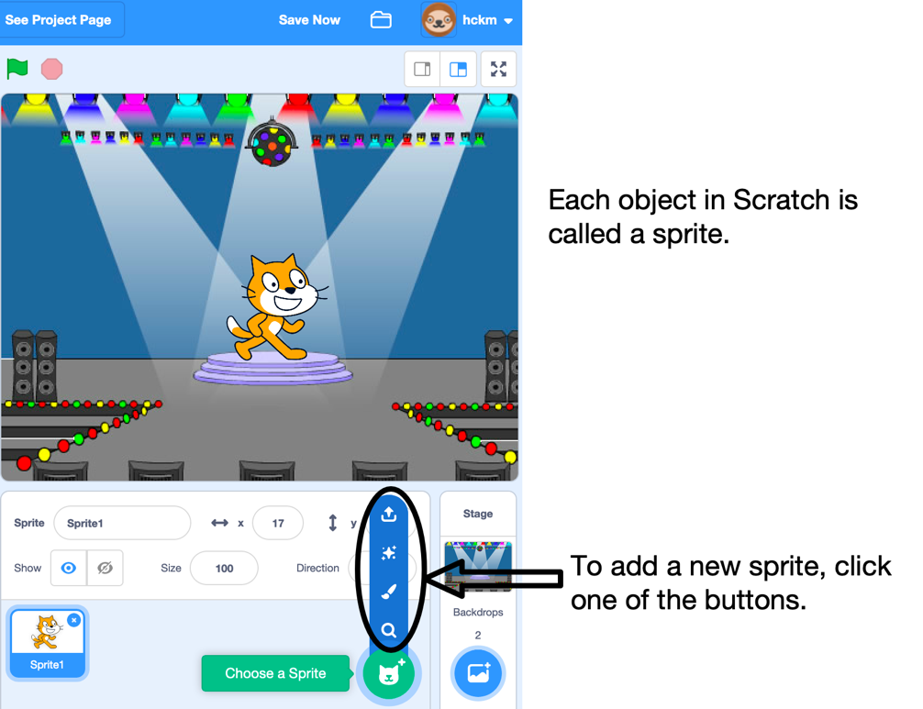
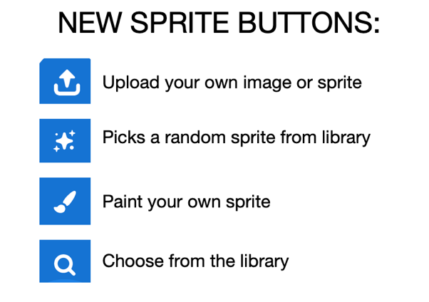
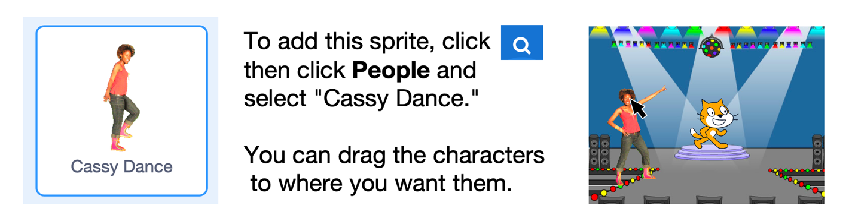

Animating

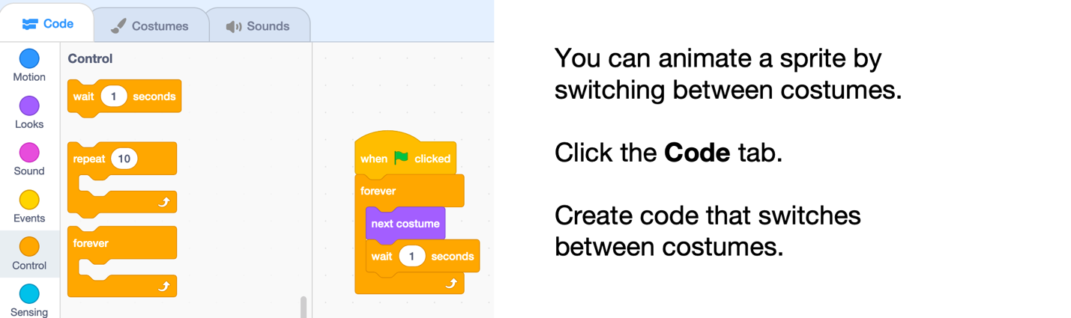
Good work, you have completed the Getting Started with Scratch tutorial!

