Managing Classes with Scratch Teacher Accounts
Coding & STEAM 2019

Introduction
In this activity, you will learn about some important features of Scratch Teacher Accounts. A Teacher Account allows you to manage Classes of students and can make common administrative tasks, for example: setting up students' accounts and changing students' passwords, easier. We highly recommend requesting a Teacher Account on the Scratch website, if you are going to use the online version of Scratch with your students.
The features of the Scratch Teacher Accounts we will focus on in this activity are:
- Creating a Class
- Adding Students to Classes
- Creating Class Studios
- Changing Students' passwords
- Viewing Students' Activity
Teacher Accounts in Scratch are relatively new, so there may be changes to the Teacher Account features or new features introduced soon. For more information about what Teacher Accounts can and cannot do, and the planned changes to how they work, we recommend reading the Scratch Teacher Account FAQ.

Key Teacher Account Concepts
In this activity, there are several concepts/terms that we have used frequently. We have included a short description of these frequently used concepts/terms, in case you need to know what these mean or refer to them when working through the different sections of the activity.

Student Account
A Student Account is a Scratch account that has been created by a Teacher Account. Student Accounts differ to regular Scratch Accounts (those that are created by signing up on the homepage) in two main ways. Firstly, a Student Account belongs to a Class that has been set up by a teacher. Secondly, you do not need to register a student's email with a Student Account. Consequently, if one of your students with a Student Account forgets their password and cannot log in to their account, you will have to change their password using your Teacher Account.
Currently, a Student Account can only belong to one class and the account cannot be changed to another class. For example, if a teacher in Year 6 has their own Classes, the Student Accounts in the Year 5 teacher's Class cannot be transferred to the one of Year 6 teacher's classes at the end of the year. This is discussed in more detail in the What are Classes in Scratch? section of this activity.

Teacher Account
A Teacher Account is a Scratch account that has been requested from, and approved by, the MIT Scratch team. With a teacher account, you can create and manage Classes of Student Accounts, as well as access Educator Resources.
When you are signed into a Teacher Account in Scratch, you will see a purple banner at the top of the homepage, as shown in the picture below:
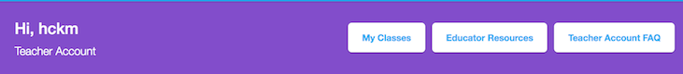
You may also notice that, in the menu at the top-right of the screen you will have an extra item: My Classes when signed into a Teacher Account, as illustrated below:
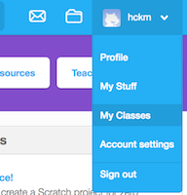
In addition to allowing you to manage Classes, Teacher Accounts also allow you to use Scratch to create, remix and share projects, just like you can with regular Scratch accounts.

Classes
In Scratch, Classes are a collection of Student Accounts For example, if you teach a Year 5 class, then you might create a Class that has Student Accounts for every student in the Year 5 class.
How you use Classes will depend on what works best for your students. Different approaches of using Classes are discussed in more detail in the What are Classes in Scratch? section of this activity.

Class Studios
A Class Studio is a collection of Scratch projects that belongs to a Class. You can create as many Class Studios for a Class as you would like, and every Student Account in that Class will be able to view and add projects to them.
There are several reasons for using Class Studios. For example, you could set up a Class Studio as a way for students to submit a Scratch program for assessment. Once students complete their project, they can share the project and add it to the Class Studio for you to view and assess. Other reasons for using Class Studios are discussed in the What are Class Studios? section of this activity.

Creating a Class

What are Classes in Scratch?
One of the most important concepts in this activity is: Classes. In Scratch, a Class is a collection of Student Accounts. You can create as many Classes as you would like and each of these Classes can have as many Student Accounts in them as you would like. Currently, Student Accounts can only belong to one Class and cannot be moved between different Classes. Additionally, if your students are already using Scratch and have their own regular Scratch accounts, you cannot add their regular Scratch accounts to a Class. However, the ability to move Student Accounts between Classes and add regular Scratch accounts to Classes may be added in the future.
If you decide to use Scratch Teacher Accounts, the way that you will create use Classes for your school will depend on how many classes you teach and whether different teachers at your school also use Scratch. For example, if you teach a Year 5 class Mathematics with Scratch and another teacher sees the same class for a stand-alone ICT lesson that also involves Scratch, you may want to set up a shared account with the teacher that runs the ICT lesson. This way, your students can use the same username and password in your class and in the ICT lessons. Additionally, you and the ICT teacher will also be able to see students' activity and manage their accounts as well.
If you have any other questions about using Classes, or if you already using Classes and would like to share how you use them with your students with us, please let us know.

Adding a New Class
Now, we will add a new Class using your Teacher Account.
You can get to the My Classes page, where you can view and manage your Classes, by clicking on the My Classes button in the purple banner on the Scratch homepage or by clicking the My Classes link in the drop-down menu on the top-right of the screen.
To add a new class, click the + New Class button and you should see a form that looks like the one pictured below:
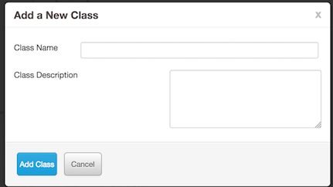
You are welcome to name the Class with any Class Name and put in any Class Description that you like. However, you should be aware that the Classes, Student Accounts, Class Studios and your students' shared projects can be viewed by anyone on the Scratch website. Consequently, when you create a Class for your students you should probably not put information about the Class in the Class Name or Class Description textboxes that could reveal your school or the identity of your students.
After choosing a Class Name, writing a Class Description and clicking the Add Class button, the Add a New Class form should disappear and you will see the newly created Class in the All Classes list.
In the next section you will learn about how to add Student Accounts to a Class.

Adding Students to Classes
There are currently three different ways to add Students to a Class with Scratch Teacher Accounts:
- Adding Students with the + New Student button
- Creating a Student Sign-up Link
- Adding Students with CSV Upload
Each of these methods of adding students are slightly different and none of them is the "best way". If you decide to use Scratch Teacher Accounts with your classes, you can use whichever of these methods you like. We discuss one approach that you could use in the “Extension: Using CSV Upload to Create Classes” activity, which is available on the Week 2 page of the Coding and STEAM 2019 website under the Activities heading. In that document, we explain an approach that we have used successfully for creating accounts for professional development programs. However, you may find that one of the other approaches is better suited to your students and classrooms.

Adding Students with the + New Student button

How the + New Student Button Works
The + New Student Button allows you to add Student accounts to a Class one at a time. When you add a new student with this approach, you choose their account's username. The new student can then log in by using the username and the name of your account as the password. So, for example, if your Teacher Account's name is ScratchTeacher, then the first time the student logs into their account that you have created with the + New Student button, they will use the password: ScratchTeacher to login. Once that student has logged in to Scratch, they will then be prompted to choose a new password.
This method of adding students can be quick and easy, if you want to create Student Accounts for a small number of students. If you have a class of 20 or more students and want to create accounts for all of them, we would recommend that you use one of the other approaches discussed in the next sections.

Add a Student with the + New Student Button
To add a student, click the + New Student button in the Students tab, when viewing the Class you created in the previous activity section. You should now see a form that looks like the one pictured below:
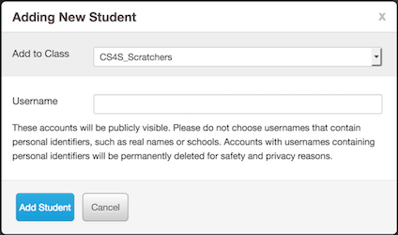
Try and see what happens when you enter a common name (for example: Bob) in the Username textbox and click the Add Student button.
You are likely to get a message that says: Sorry, that username already exists. As Scratch has over 20,000,000 members, it may be difficult to find usernames that have not already been taken when creating accounts for your students.
Generally, when creating accounts for workshops we suffix the username with a meaningful acronym (for example: CS4S for Coding & STEM 4 Schools) and then use a combination of random colours, animal names and numbers for the rest of the username. For example, we may use usernames like BlueDog22_CS4S for the accounts we create, because they do not contain names or other words that could identify who the account belongs to and they are also unlikely to be already taken by someone else.
You may want to take a similar approach when you create a class of students, but you are welcome to use any usernames of your choosing for this activity. Now, add a Student with the Adding New Student form by creating a unique username and clicking the Add Student button. If all the usernames you think of are not unique, keep trying to complete the form until you create a username that does not already exist or ask one of the session presenters to help you come up with a unique username.
When you have successfully added a student, the form pictured above will disappear and the Student account you just created will appear in the list of accounts in the Students tab.

Log into the New Student's Account
Now we will log into the newly created Student's account, so that you can see what the student will experience when logging into their account created with + New Student button.
Firstly, open another web browser (for example: if you are using Firefox - open Chrome as well). In that web browser, go to the Scratch homepage at scratch.mit.edu.
Log in to the Scratch account you created by clicking the Sign in button and:
- Put the username of the Student account you created in the steps above in the Username textbox
- Put the name of your Teacher Account in the Password textbox
Once you have logged into the student's account, you should see a message about being invited to the Class you created earlier. Click the Get Started button and you will then be prompted to choose your own password. Once you have chosen your own password, you will have to complete a form of personal details. After completing that form, you have now finished logging in to the new Student account and will then be able to view the Class from that account's perspective.

Summary
- The + New Student Button allows you to add Student accounts to a Class one at a time
- This approach requires that you choose a (unique) username for each of the Student accounts you create
- The Student account's password, when they first log in, will be the username of your Teacher Account
- The Student will be prompted to change their password once they have accepted the invitation to the Class, after logging in for the first time
- This approach can be quick and easy for creating a small number of accounts for students but the other approaches in the next sections may be better for 20 or more students

Creating a Student Sign-up Link

How it Works
The second method for creating new accounts in a Class involves generating a Student Sign-up Link. When you choose to generate a sign-up link (through the Student Sign-up Link button on the Class page) you will be given a website link that you can share with your students. When students follow this link, they will be able to accept an invitation to join the Class and choose their own username and password for their new account.
The form for creating the sign-up link, which is pictured below, is simpler than the other forms for creating Student accounts that we have looked at in previous sections.
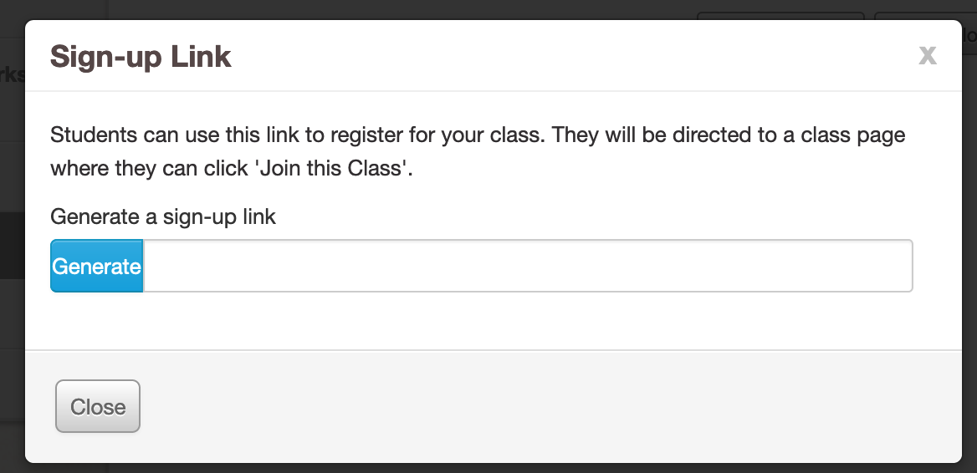
You will be given a link that looks like the link below (don't worry about copying this into your web browser, this is just given as an example).
http://scratch.mit.edu/classes/57468/register/8b71542e29fc4df78c12e3c92eecb8df
You could share then this link using your preferred method of sharing website links with your students. For example, you could send an email to your class that includes the sign-up link.
The students could then follow the link to register a Student Account, that will be a member of the Class you created earlier in the activity.

Create a Sign-up Link
In this part of the activity you will create a sign-up link, that students can use to sign up for a Student Account.
In the web browser that you have logged in to your Teacher Account, go to your Class page and click the Student Sign-up Link button.
Next, click the Generate button and a web link, like the example link given above, will appear.
Copy this web link - you will need it in the next step of the activity.

Register as a Student Account
In this part of the activity, you will use the sign-up link you created in the previous steps to register as a student for the Class you just created.
Firstly, go back to the web browser that you had opened to log in to the account in the previous section, where you learned about the CSV Upload feature, and sign out of that account. Next, paste the web link you generated in the previous steps into the web browser's address bar and go to that website.
You should now see a webpage that explains that you have been invited to join a Class. This time, after you accept the invite, you will notice that you are asked to choose a username and password. Note that, if you use this approach for creating accounts for your students, you will have to make sure that the students understand that their chosen username must be unique, and that the username should not include names or words that could identify them. One potential disadvantage of this approach is that you do not get to choose exactly what students' usernames will be. Consequently, you may have to review the students' chosen usernames to make sure they do not include identifying information.
After choosing a username of your own choosing, you will then be asked to provide some personal details. Once you have filled in these details, you will then be signed into this new Student Account and you will be able to view the Class from the newly created account's perspective.

Summary
- The Student Sign-up Link feature can be used to create a web link that can be shared with your students
- When students follow the link, they can register an account for your Class with their own chosen username and password
- When you use this approach, you cannot easily prevent students from creating usernames that contain names or words that might identify them
- Sharing a link with your students may be simple (for example: through email) and so you may find this to be quicker and easier approach for creating accounts than the CSV Upload approach

Adding Students with CSV Upload

How It Works
The last method that we will look at is the CSV Upload approach, which is effective for creating lots of Student accounts quickly. The CSV Upload involves creating a csv (comma separated values) file that has a list of the usernames and passwords for the new Student accounts you would like to create.
An example of the format of the csv file that is expected for the CSV Upload is shown in the image below.
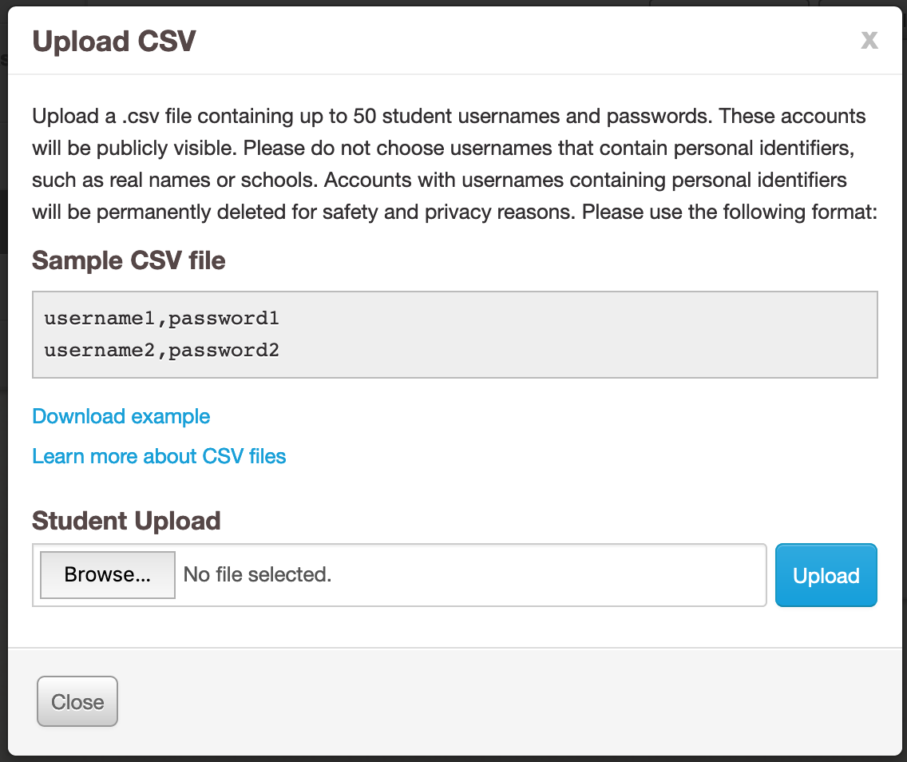
The Sample CSV file in the above image has 2 lines and therefore, when uploaded, would result in the creation of 2 Student accounts:
- One account with the username: username1 and password: password1
- The other account with the username: username2 and password: password2
We will step through the process of creating our own csv file and uploading it in the next part of this section.
As you saw in the previous section, new Student accounts must be named uniquely. If one or more of the usernames in the csv file is already taken, a message will appear that alerts you that the username/s already exist.
Using the accounts in the example above, if we try and upload a csv file with username1 and username2 as the new account names, we will receive the following error message:
- Row 1: username: Already exists
- Row 2: username: Already exists
- Please update the CSV file to address the issues above and reload the file.
This error message is telling us that the username on Row 1 (the first username in our csv file) and username on Row 2 (the second username in our csv file) have already been registered by other Scratch users. If we changed these usernames so that they were unique and uploaded the csv file again, then the error message would disappear and the newly created Student accounts would appear in the Students tab of the Class.
If you do use the CSV Upload approach, every username in your csv file may be unique and consequently you may not encounter this problem. However, it may be useful to know that if you do see the error message about the usernames already existing (or another error message), then none of the accounts will be created until you have fixed the problem and uploaded the csv file again.

Create and Upload a CSV File for New Student Accounts
Now, we will add two new Student accounts to our Class by creating and uploading a csv file.
You can create a csv file in several programs, including Excel, or in any plain-text editor (for example: Notepad on Windows or TextEdit on Mac OSX). In this example, we will use the Notepad program to create the csv file.
There are two lines below that you will have to write into Notepad. You will have to replace the first two (^^) letters in the lines below with your initials, to ensure that the usernames in the csv files are unique.
^^_CSVUpload_STEAM_1,password1
^^_CSVUpload_STEAM_2,password2
For example, if your name is Arthur Smith, the first line of the file in Notepad will be AS_CSVUpload_STEAM_1,password1
After adding these two lines in a document in Notepad, save the file in a place on the lab computer that is easy to find (for example: the Desktop).
Back in the web browser that you have logged into your Scratch Teacher Account, follow these steps:
- Click the CSV Upload button in the Students tab of your Class
- Click the Browse button and select the file you just created in Notepad
- Click the Upload button
After following these steps, the Upload CSV form will disappear and the two new accounts from the csv file should now appear in the Students tab of your Class.

Log in to One of the Student Accounts
Now, we will log into one of the Student Accounts you created through the process of uploading the csv file. Go back to the web browser that you had opened to log in to the account in the previous section, where you learned about the + New Student button, and sign out of that account.
Now, click the Sign In button and log into one of the accounts you created through the CSV upload.
If your name is Arthur Smith, you could sign into one of your newly created Student Accounts by:
- Putting AS_CSVUpload_STEAM_1 in the Username textbox
- Putting password1 in the Password textbox
Remember that you created Student Accounts that had your initials in the username and so the AS letters in the example above would be replaced with your initials.
You may notice that, unlike the previous section where you logged in with a Student Account created with the + New Student button, you are not asked to change your password. The password for this account will remain the same as the password in the uploaded csv file, unless the student decides to change it or you change the password (when logged into your Teacher Account).
You will have to accept the invitation to join the Class when first signing into this account. Once you have accepted the invitation and filled in your personal details, you will then be able to view the Class from the newly created account's perspective

Summary
- The CSV Upload approach is effective for creating lots of Student Accounts quickly.
- There is a specific format for writing usernames and passwords of the new Student Accounts in a csv file
- Every username in the uploaded csv file must be unique and the passwords must also be longer than 6 letters
- You can create a csv file that contains the list of Student Accounts with a text editor, such as Notepad, or in another program like Excel
- Unlike the other approaches for creating a Student Account in a Class, students are not asked to change their password when they first log in

What are Class Studios?
Studios in Scratch are collections of projects that you and your students can view and add projects to. You can create Studios for a Class in Scratch, which we call Class Studios.
You can view the Class Studios for a Class by looking at the Studios tab of a Class page. An example of a Studios tab on a Class with 3 studios is pictured below:
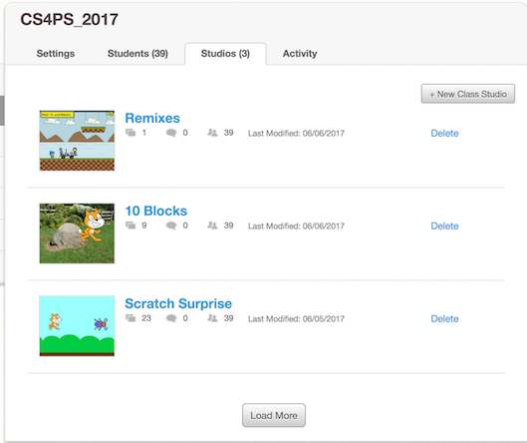
You and your students can add any project that has been shared to a Class Studio, including any projects that you, your students and other Scratch members have created and shared. You can use Class Studios in a variety of different ways and you do not necessarily have to use them as a way of collecting your students' projects.
For example, you could use a Class Studio to provide students with examples of projects that they could use for inspiration for their own projects. Let's say that you have asked your students to create a game or animated story that includes a maze. You could create a Class Studio and add examples of projects that other Scratch members have created and shared (for example: a game where a character must escape a maze). Your students could then view the projects in this Class Studio to help them come up with ideas for their own project.
Alternatively, you may want to create a Class Studio for an assessment task. You could ask your students to share and add their project into this Class Studio once it is ready to be marked, so that you could see every assessment task submission in one place.

Create a Class Studio
In this part of the activity you will create a Class Studio. Let's say that you have asked the students to find a Scratch project that they think is interesting (using the Explore link on the Scratch homepage, for example) and you would like them to share it with the rest of the class.
To create a Class Studio, click the Studios tab when viewing a Class and click the + New Studio button.

You should see the Add a New Class Studio form appear, which will look like the image below:
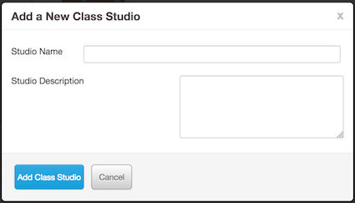
For this example, you could use the following Studio Name and Studio Description:
- Studio Name: Interesting Projects
- Studio Description: A Studio for sharing projects that you find interesting
After filling in these textboxes and clicking the Add Class Studio button, the form pictured above will disappear and you should now see the Interesting Projects studio in your Studios tab.
When you click on the Interesting Projects Studio link, you will be able to see the details for the Studio, which will look like the image below:
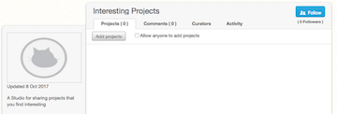
When you create a new Class Studio, every Student Account in the Class will automatically become a curator of the Studio. Curators can view and add projects to a Studio.
You may notice the Allow anyone to add projects checkbox at the top of the Interesting Projects Studio page. When this is checked, anyone with a Scratch account can add a project to the Class Studio. In most cases, you probably do not want to allow anyone to add projects to the Class Studio, so it is probably best to leave the Allow anyone to add projects checkbox unchecked. However, there may be some cases where you would allow for anyone with a Scratch account to add a project to the Class Studio. For example, some of your students may have their own personal Scratch accounts and you might allow them to use their personal account instead of a Student Account. When you create a Class Studio for an assessment task, you could check the Allow anyone to add projects checkbox and consequently the students using their personal accounts would be able to share and add their completed projects to the Class Studio. Alternatively, instead of checking the Allow anyone to add projects checkbox, you could use the Invite curators button in the Curators tab of the Class Studio to add the students using their own Scratch accounts as curators to the Class Studio.

Add a Project to the Class Studio
In this part of the activity, you will add a project to the Class Studio you created in the previous steps.
There are two ways to add a project to a Class Studio:
- From the Studio page, with the Add projects button
- From a project's page, with the Studios button
In this activity we will use the second approach. For more detail about how to add projects to a Studio and other features of Studios, see the Scratch Wiki page about Studios, available at: https://wiki.scratch.mit.edu/wiki/Studio
Now use the Explore feature of Scratch, by clicking the Explore link at the top of the Scratch website, to find a project that you find interesting. Once you find an interesting project that you would like to add to your Interesting Projects Studio, click the Add to Studio button. An example of an interesting project with the Add to Studio button highlighted by a blue rectangle, is shown in the image below:
When you click the Studios button, a list of Studio names with plus icons next to them will appear. To add a project to a Studio, you will have to click the appropriate Studio's name. After you have clicked the tick for the Interesting Projects Studio, the name will turn green, a tick will appear next to the Studio’s name and the project will be added to the Studio.
Now, go back to the Interesting Projects Studio page and you should see the newly added project.

Changing Students' Passwords
One of the most useful features of Scratch Teacher Accounts is the ability to change Student Account passwords. If one of your students forgets their password and cannot login to Scratch, you can change their password for them.
To change a Student Account's password, you will have to go into the Students tab of the Class page, find the name of the Student Account you want to change the password for, and then click on the Account Settings link below their name.
There are two different ways of changing Student Account's passwords, which are described in the Account Options form shown in the image below:
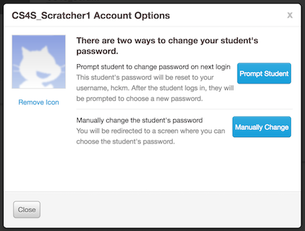
Both ways of changing Student Accounts are quick and easy ways to get a student that has forgotten their password logged back into their account.

Viewing Students' Activity
Another useful feature of Scratch Teacher Accounts is the ability to view your students' activity on Scratch. You can see students' activity by looking at the Activity tab on the Class page.
An example of activity in a Class called ScratchMaths 2018 is shown in the image below:
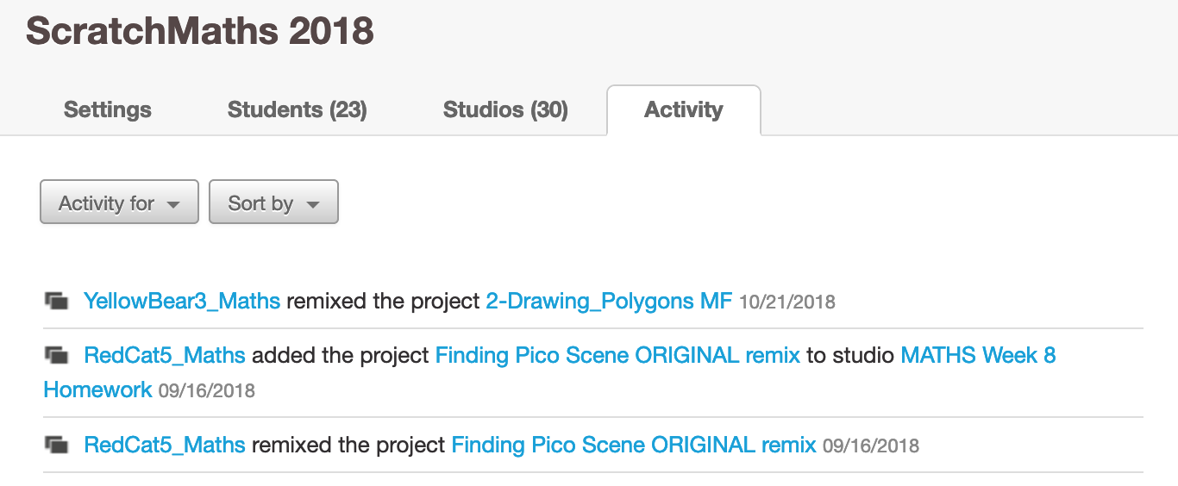

You can see many different types of activities in the Activity tab, including when a student:
- shares a project
- comments on a project
- loves a project
- favourites a project
There are some activities will also appear in the All Class Alerts section of the My Classes page. This is discussed in more detail in the next section.

All Class Alerts
Some activity in Scratch will cause an alert to appear in the All Class Alerts section of the My Classes page.
Examples of activity that causes alerts are:
- When a student is censored (for example: when they make an inappropriate comment on a project)
- When a student deletes their account
In the image below, you can see an example of an alert caused by a Student (with the username glaretram) being censored for making an unconstructive comment:
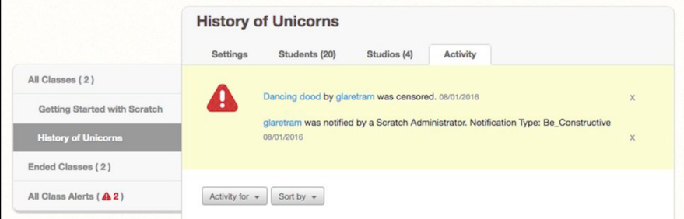

Conclusion
You have now reached the end of the Scratch Teacher Accounts activity - good work!
In this activity you have learned about the following features of Scratch Teacher Accounts:
- Creating a Class
- Adding Students to Classes
- Creating Class Studios
- Changing Students' passwords
- Viewing Students' Activity
We hope that working through this activity has helped you understand how to use the features listed above and that these features will be useful for your classroom use, if you choose to use the online version of Scratch and Teacher Accounts. This activity will also be available indefinitely on the program website for you to refer to in the future.
If you have questions about planned changes to, or the current limitations of, Teacher Accounts, we recommend reading the Scratch Teacher Account FAQ.

