Introduction to Scratch
  - Visual Programming

Introduction
This tutorial is a quick introduction to Scratch – a visual programming language that can be used to build interactive stories, games and animations.

Acknowledgements
This tutorial has been adapted using content from the Getting Started with Scratch Guide created by the Lifelong Kindergarten Group available here:
https://scratch.mit.edu/scratchr2/static/__1371843055__/pdfs/help/ScratchGetStarted_beta_draft_Jan2013.pdf

Getting Started
Scratch will run in most web browsers without installing additional software. This includes browsers such as Internet Explorer, Mozilla Firefox and Google Chrome. Today we’ll be using Mozilla Firefox, which you can open by clicking the Start Menu, going to All Programs then selecting Mozilla Firefox.
The Scratch website is https://scratch.mit.edu/ Start by opening that in Firefox.
From the website you can open the Scratch Editor (by clicking Create), see programs that students all over the world have created (by clicking Explore), or view the Scratch discussion boards (by clicking Discuss).
You do not need to register for an account on the Scratch website to complete this tutorial. If you would like to save the project so that you can work on it from home later on or to share it with others, then you will have to register an account with Scratch. You can register a Scratch account by clicking Join Scratch on the homepage, or by clicking Sign in then Or Join Scratch when in the Scratch Editor.
When you’re ready to start making a visual program, click Create to open the Scratch Editor. You should see something like the image below:
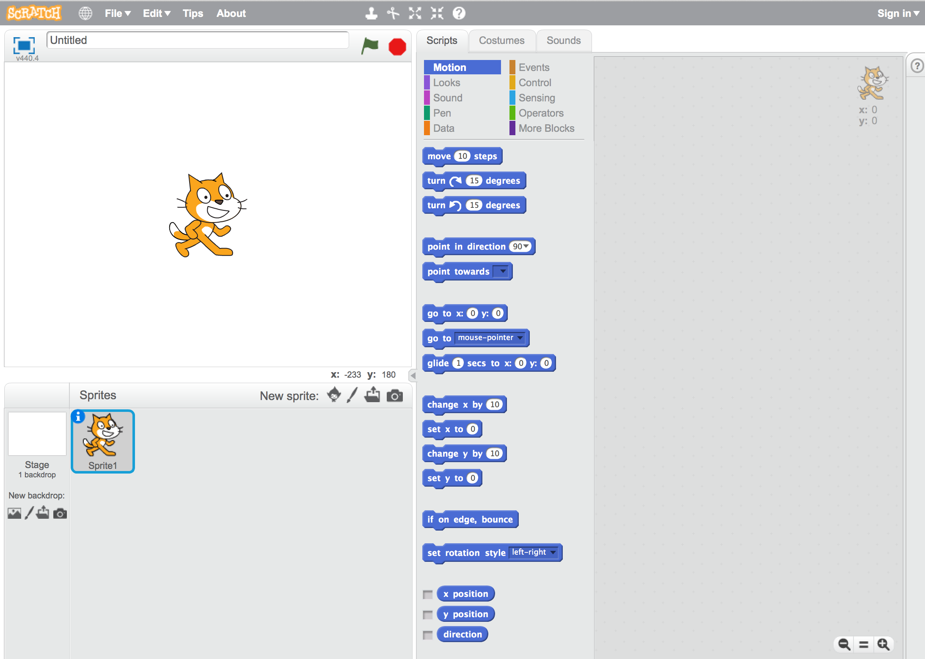

Start Moving
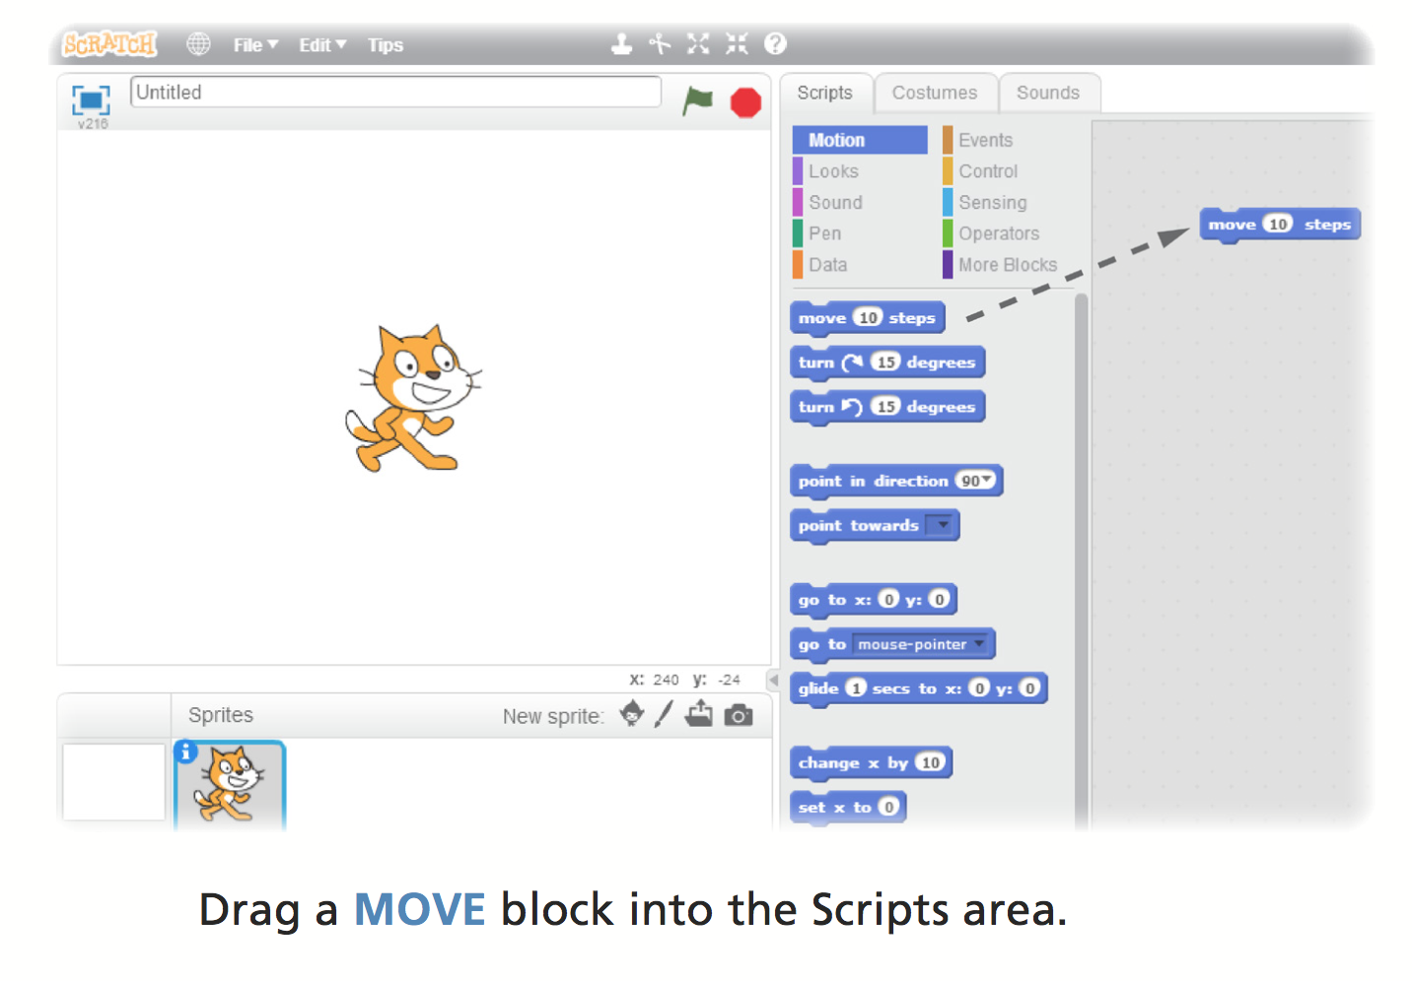
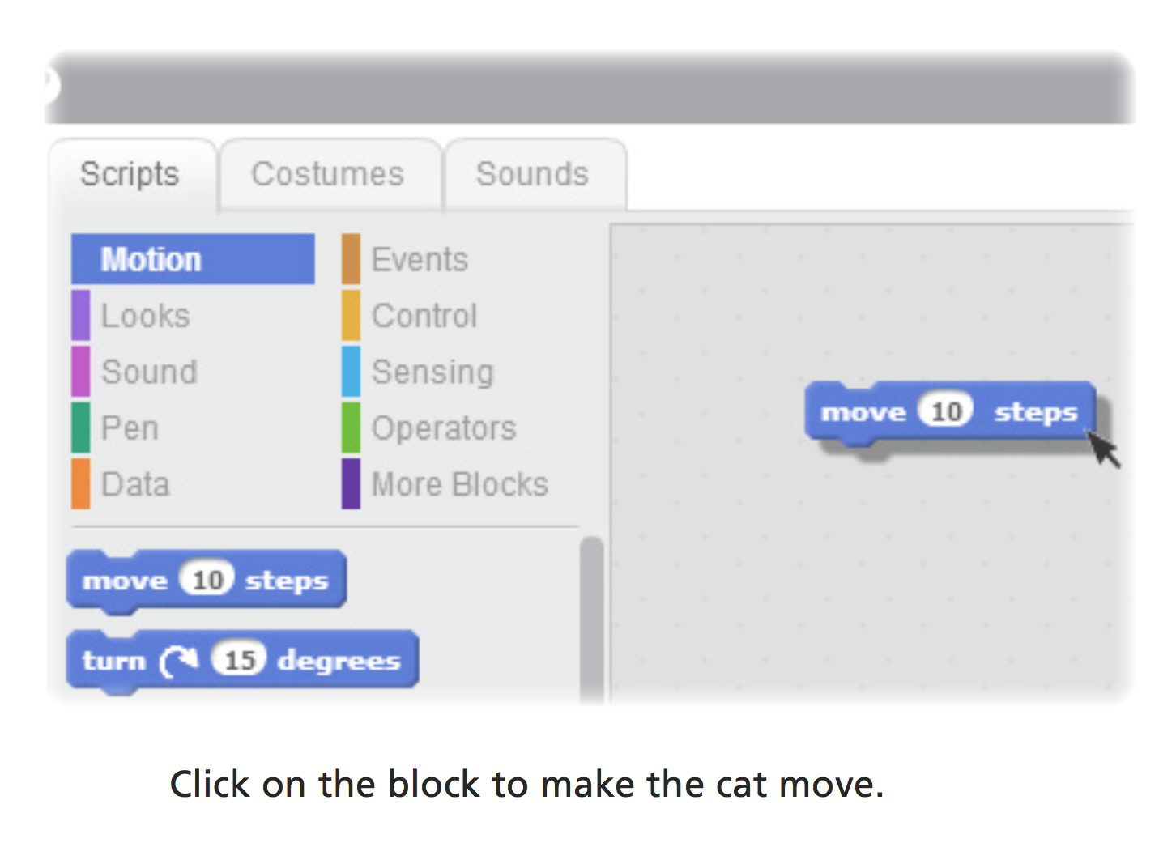

Add a Sound
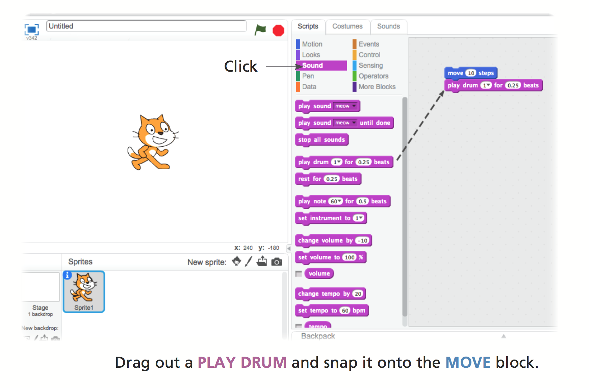
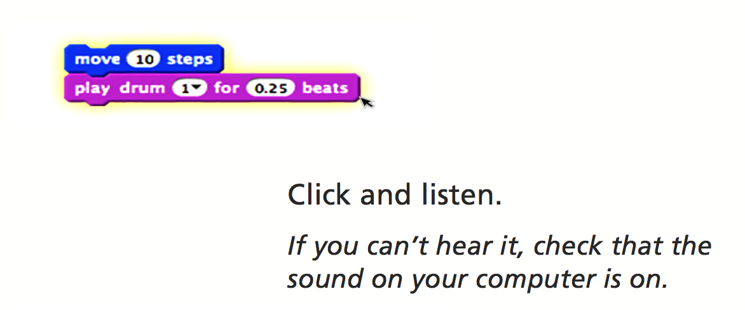

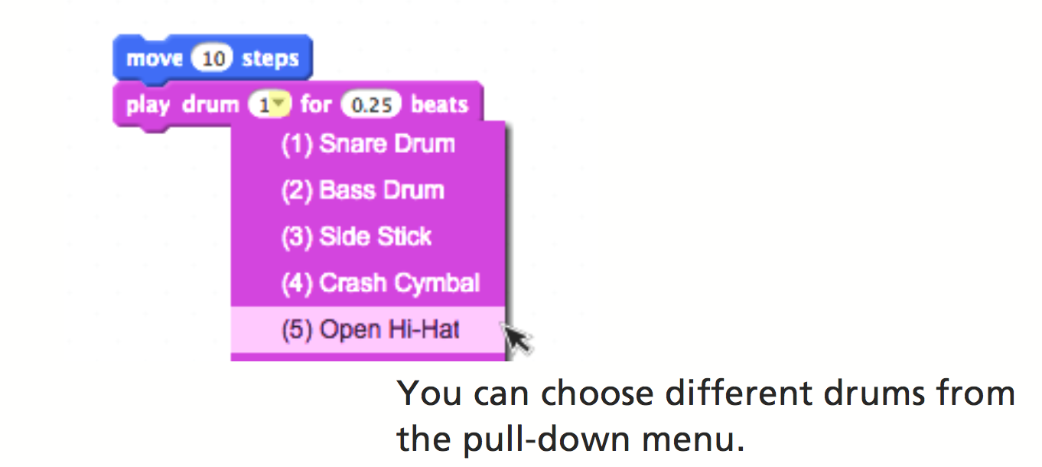

Start a Dance
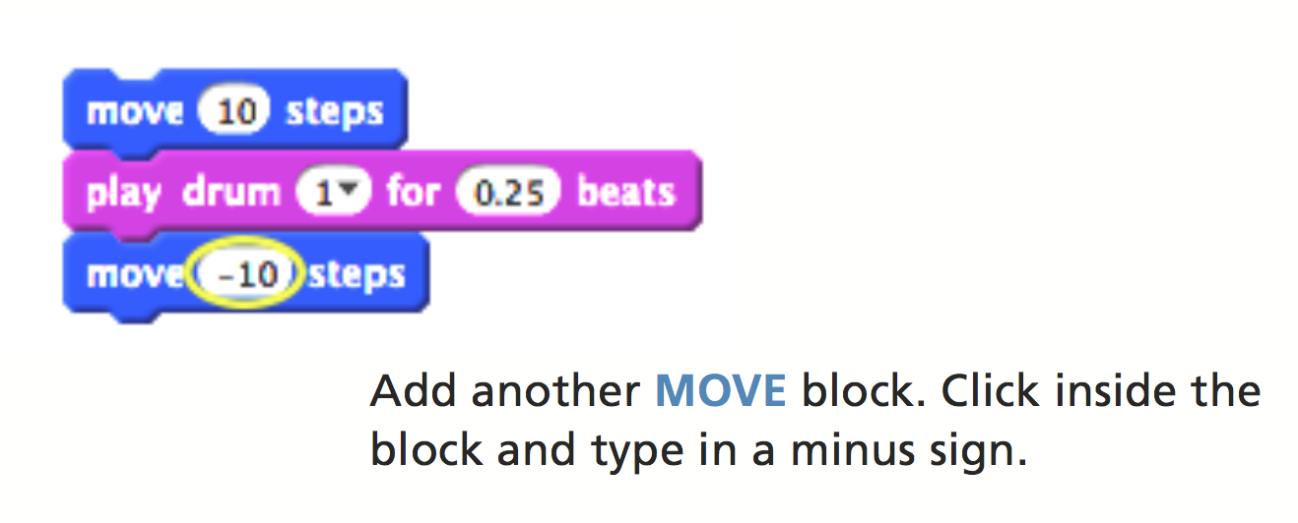
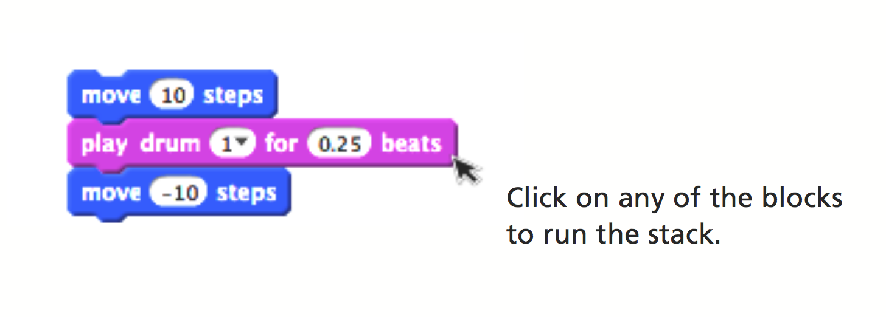
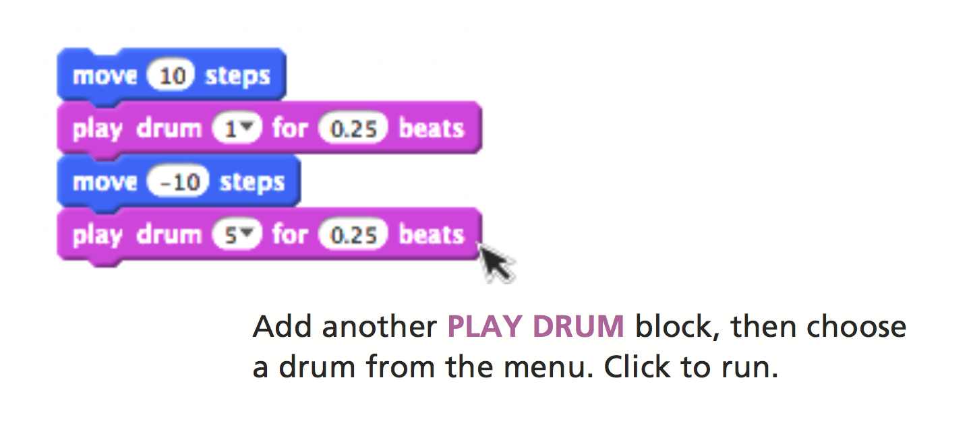

Again and Again
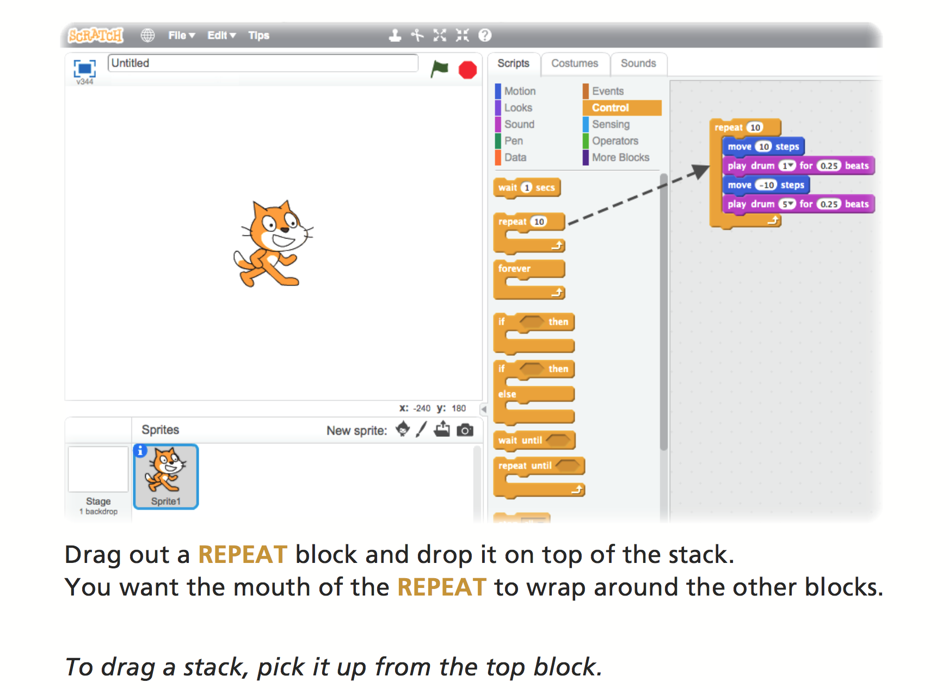
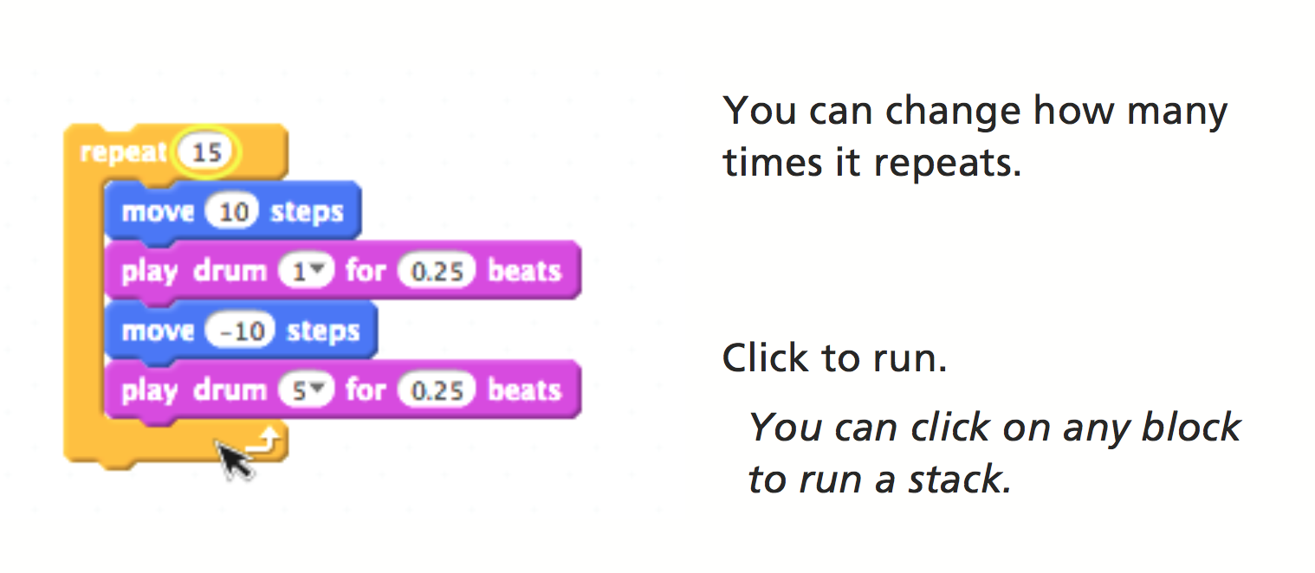

Say Something
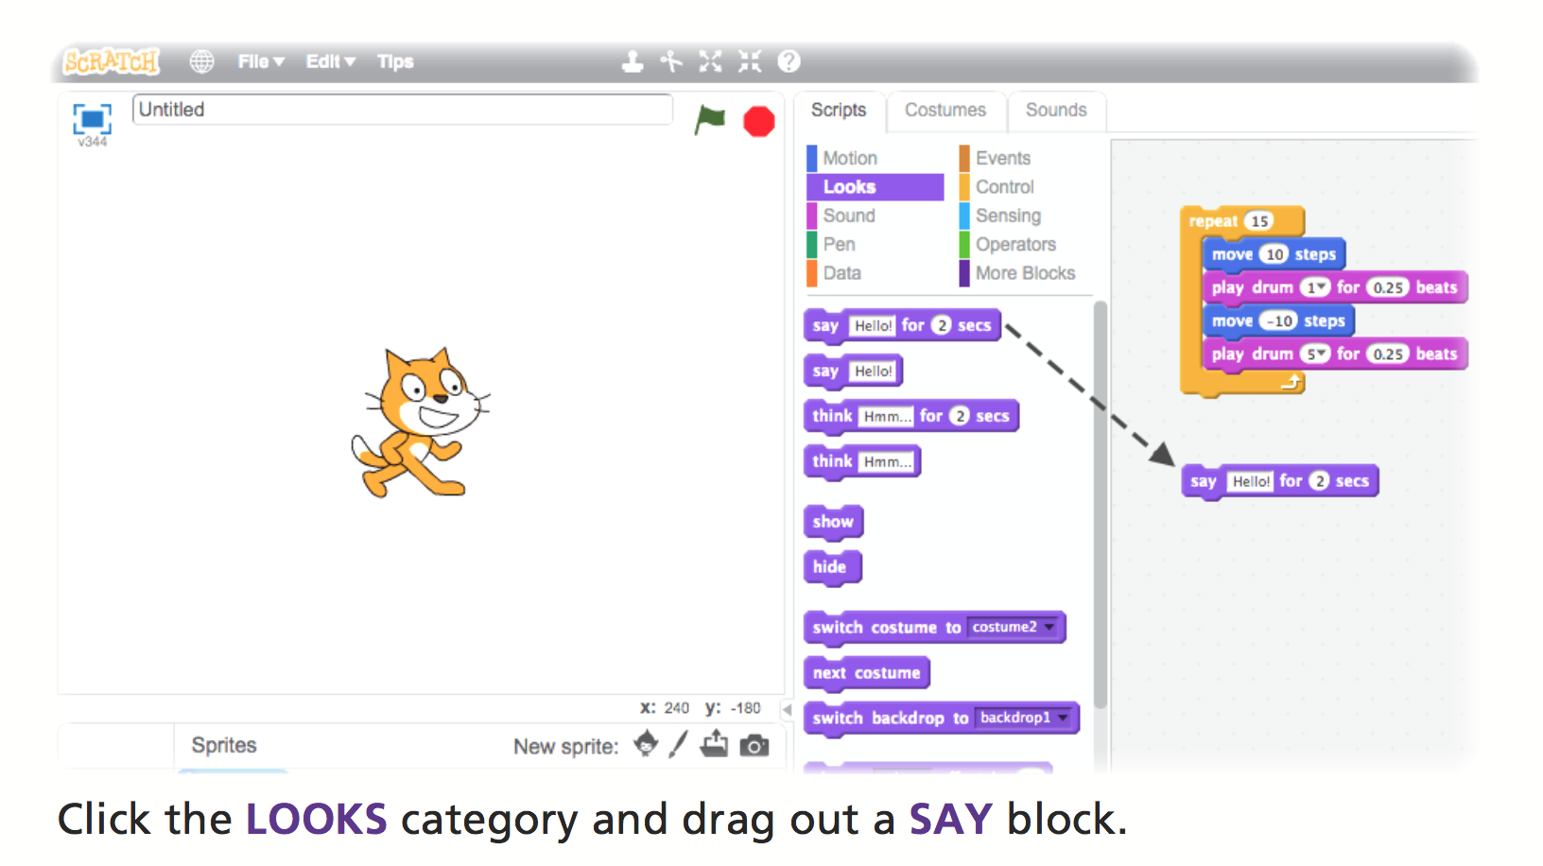
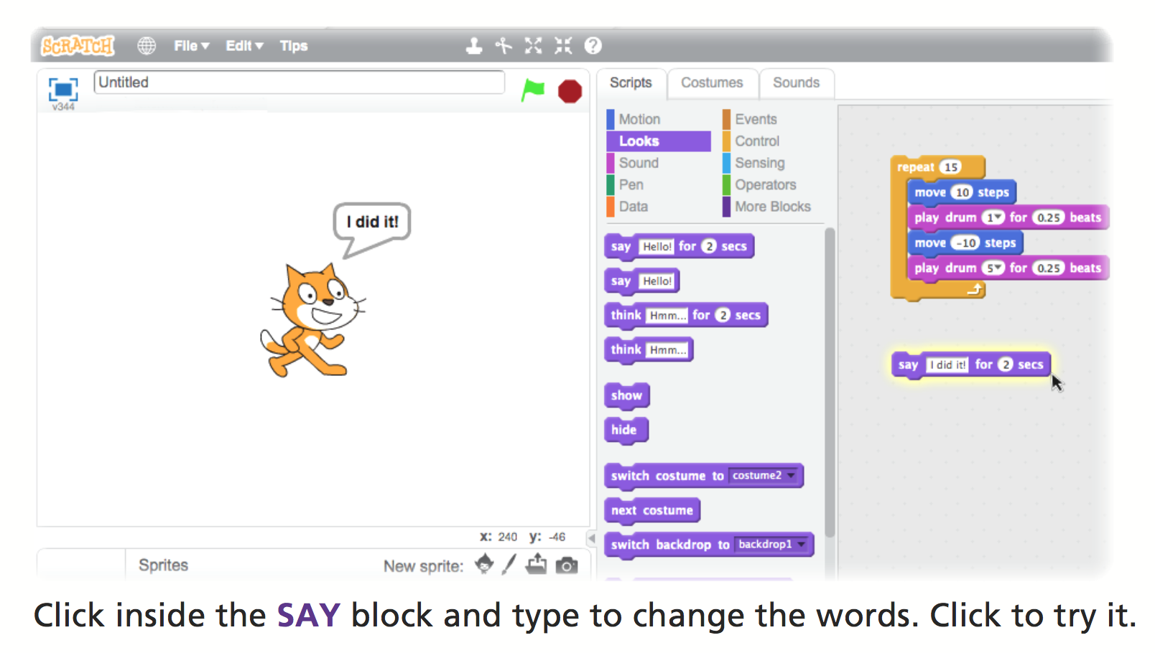
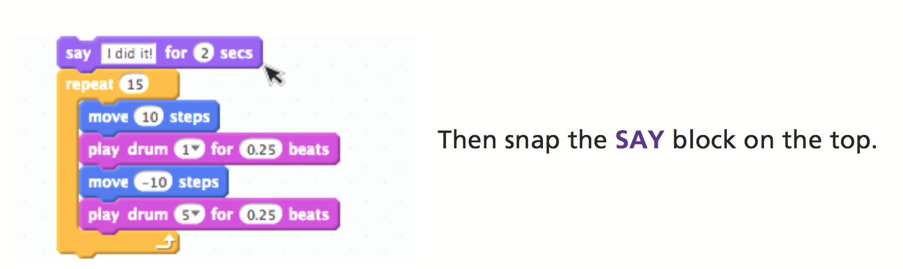

Green Flag
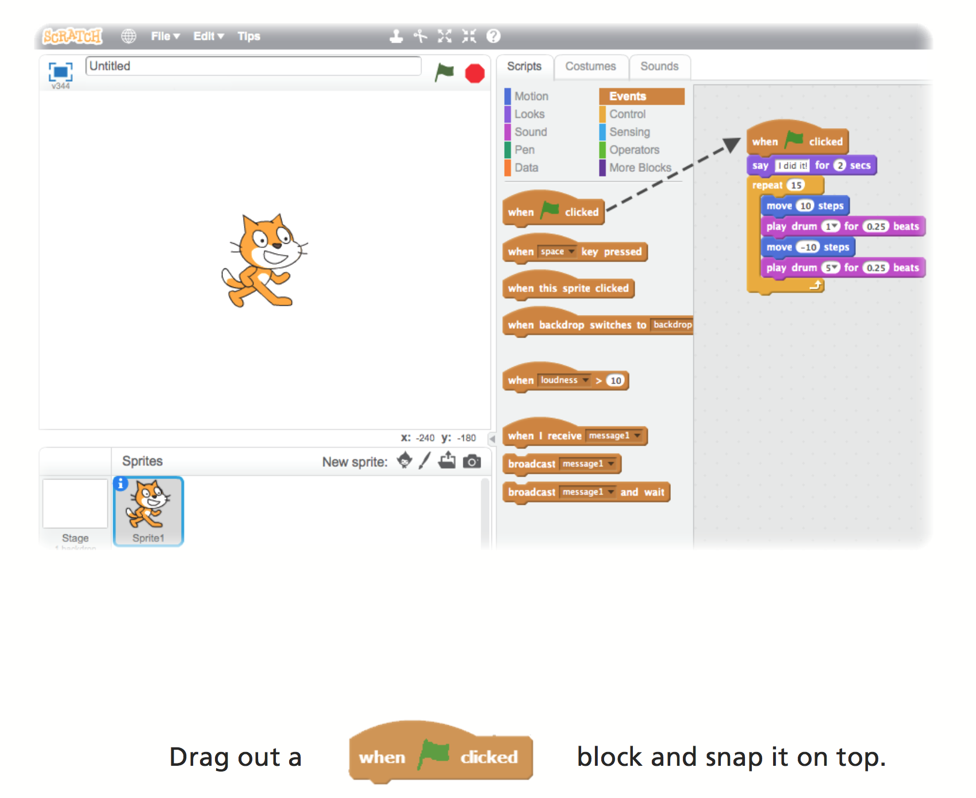
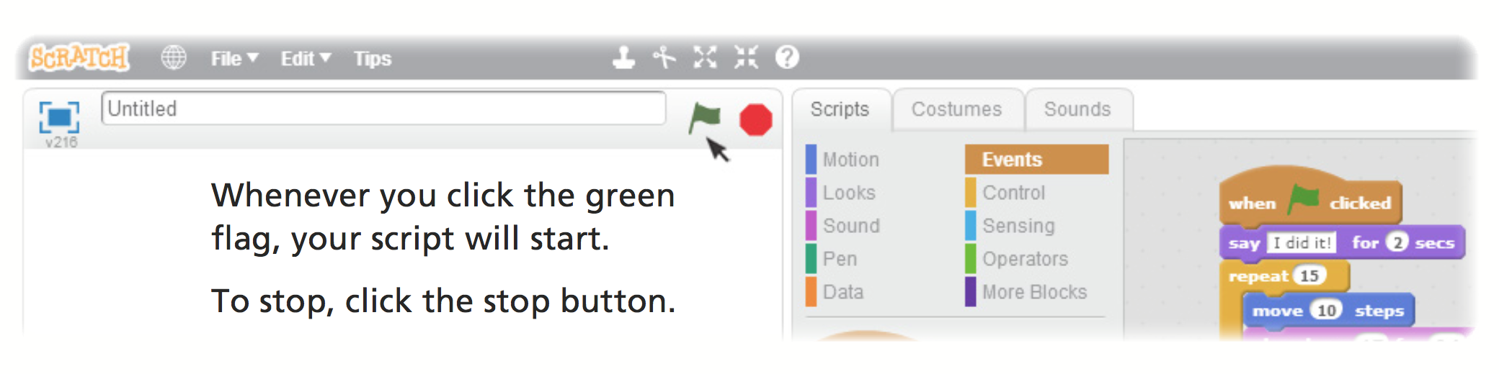

Change Colour
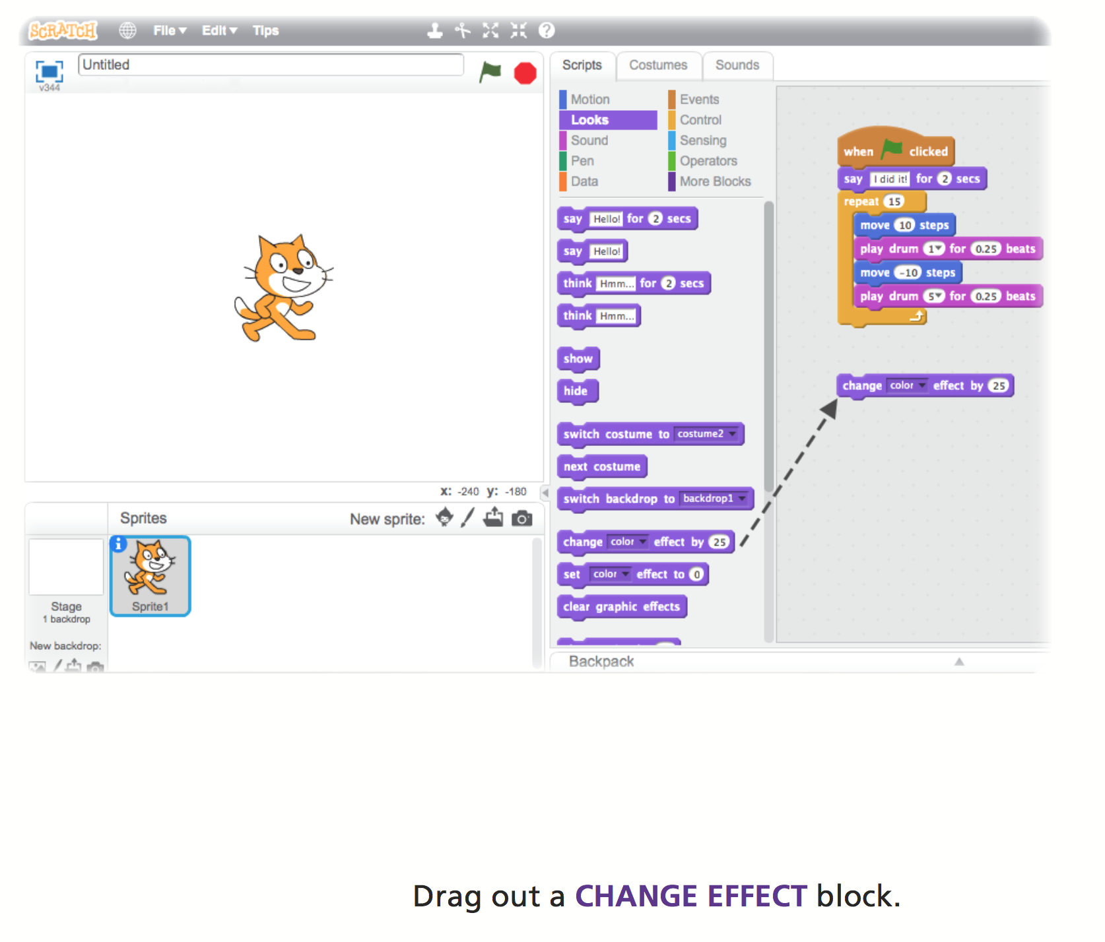

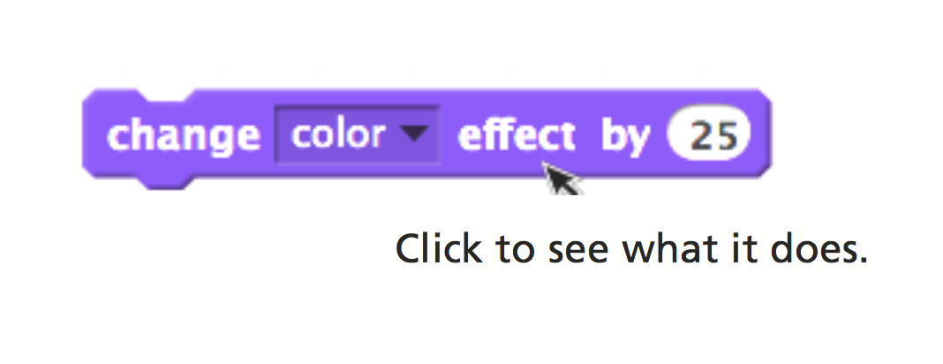

Key Press
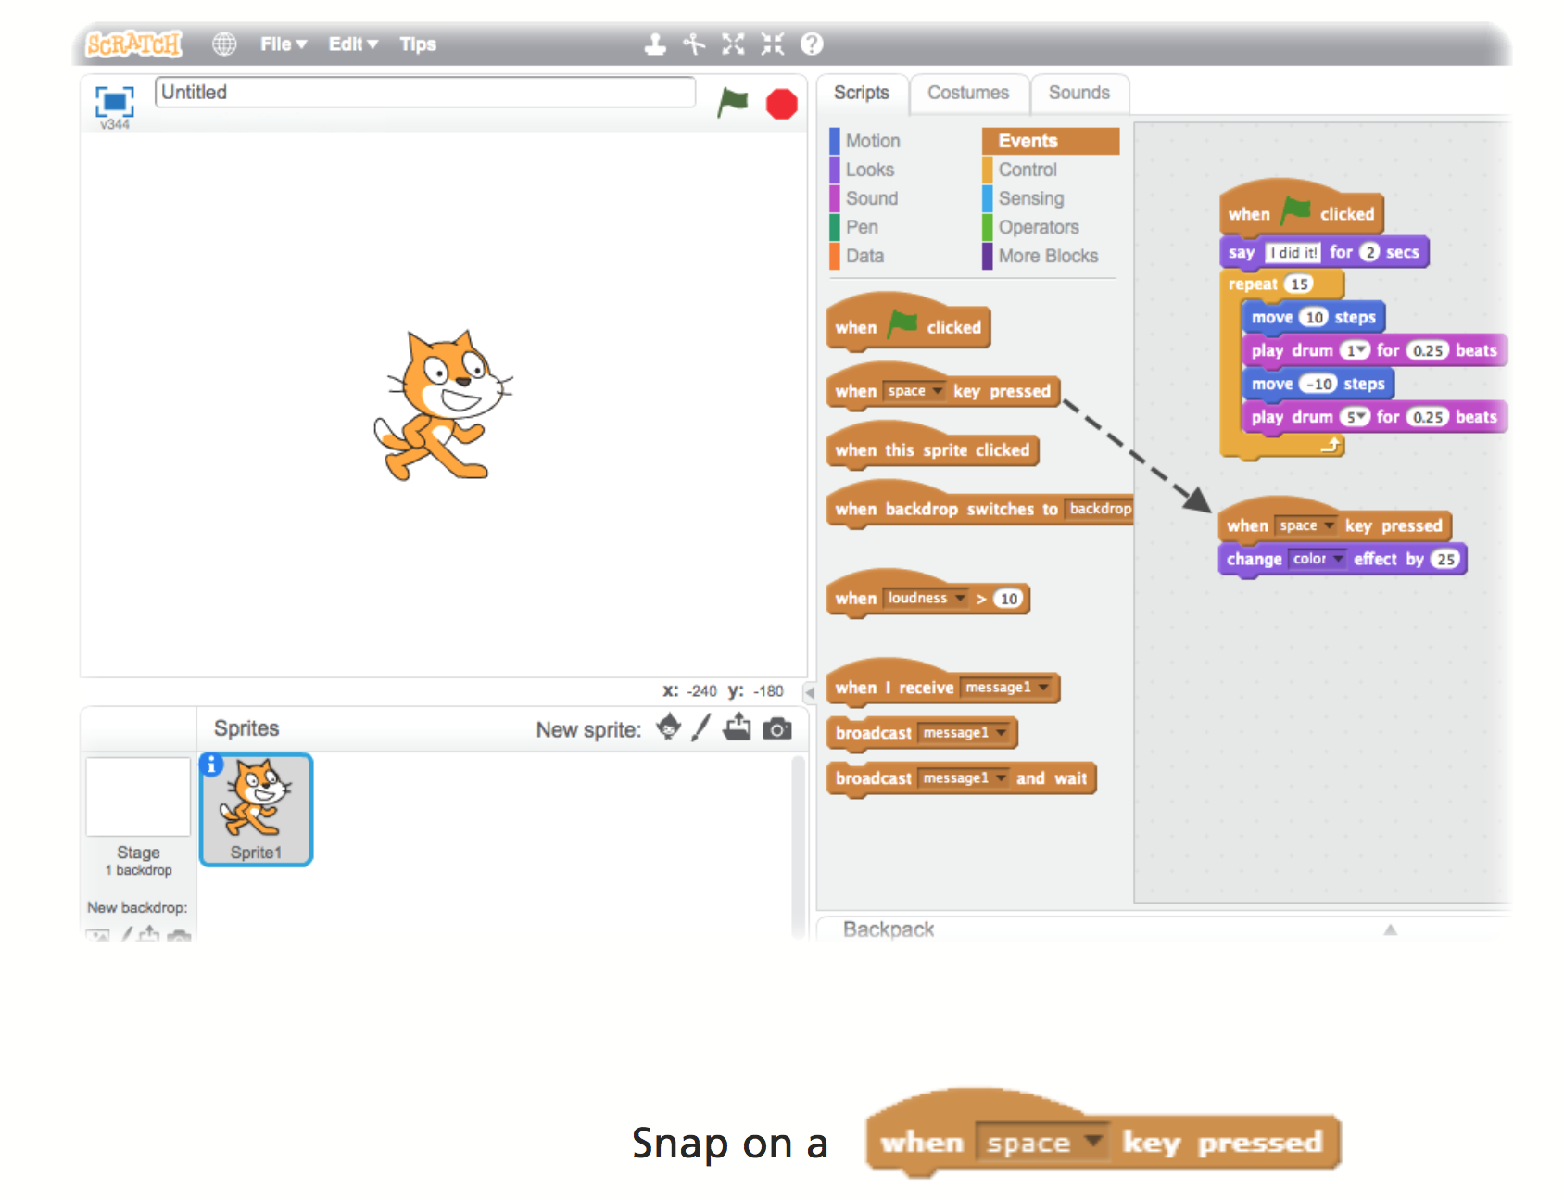
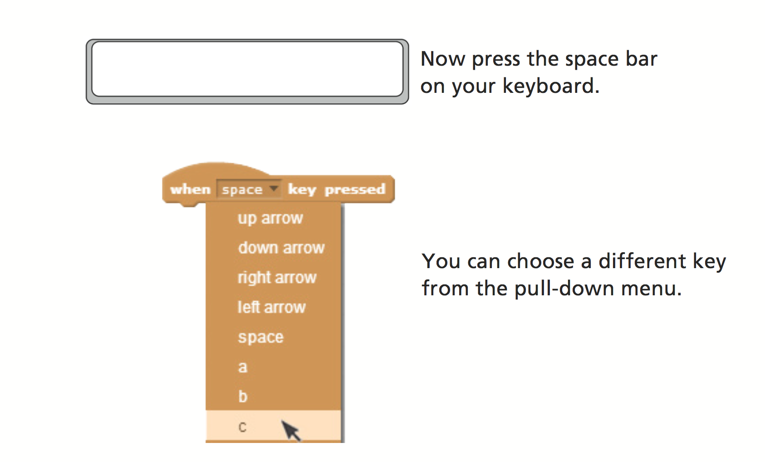

Add a Backdrop
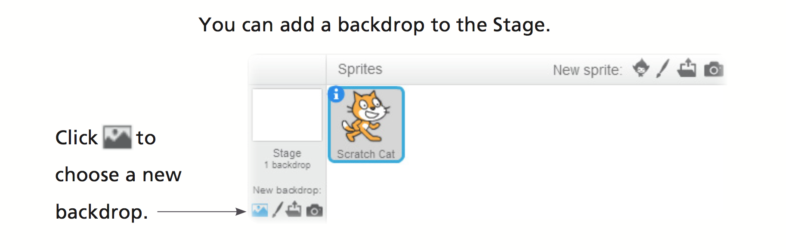
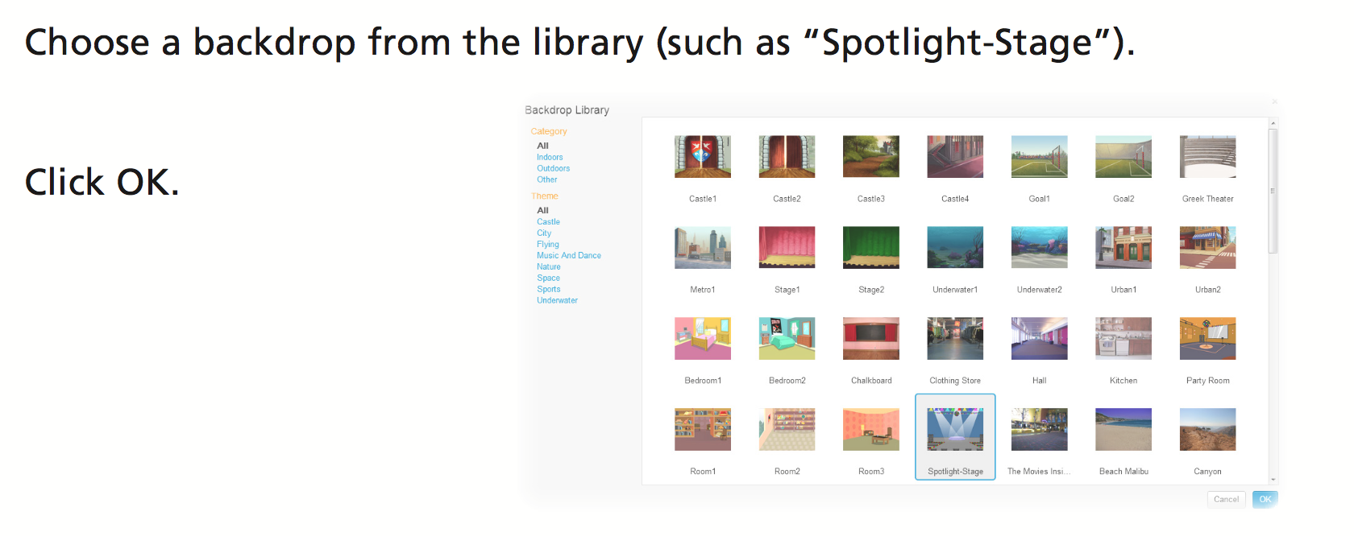
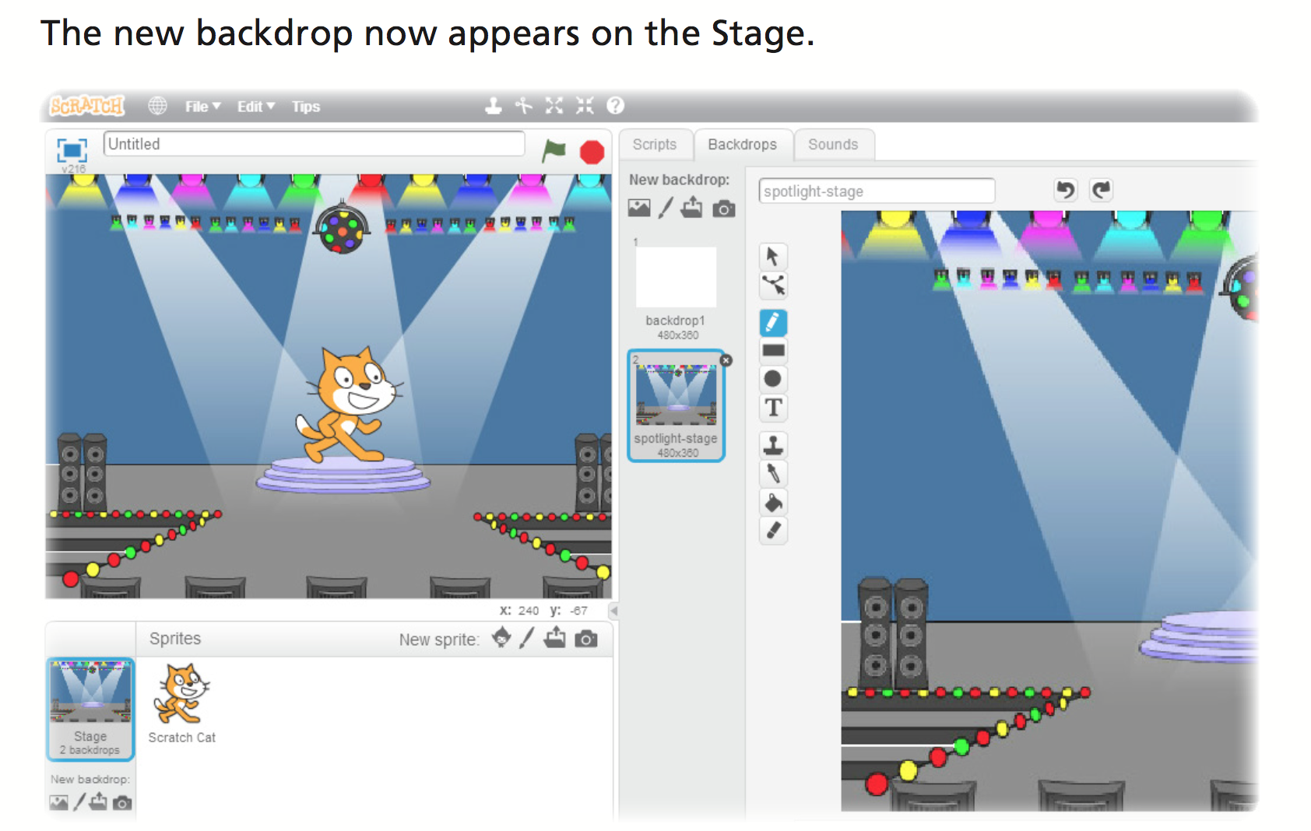

Add a Sprite

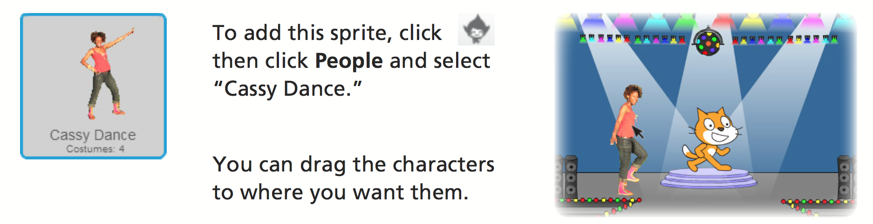

Animating
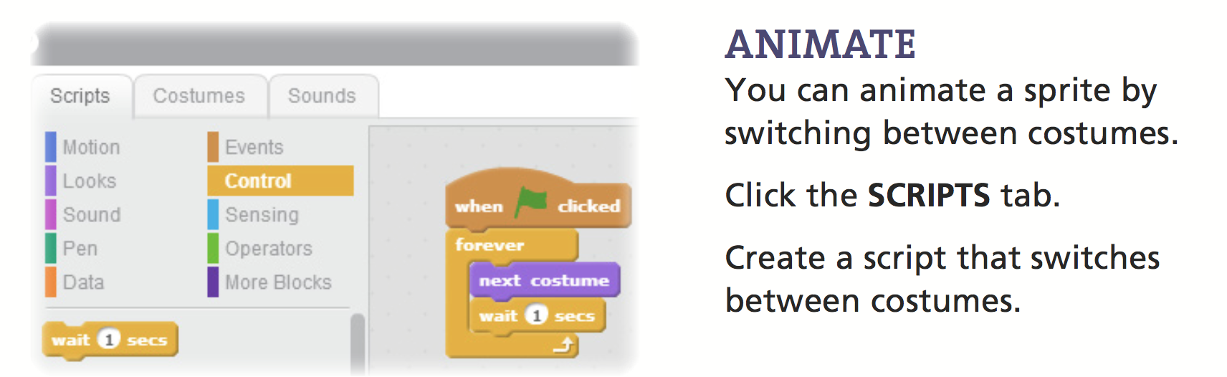
Good work, you have completed the Introduction to Scratch tutorial!

